Using Subtraction Stacks for Math Fact Fluency:
- Derived Fact Strategy Game for Subtraction
- Targeted Facts: Differences of five or less
- Students need explicit instruction and significant opportunities to practice subtraction strategies. Without these opportunities, students can depend on Counting Up or Counting Back in situations where these strategies are not efficient.
- One key to developing fluency with subtraction facts is helping students to recognize the distinction between take away and compare situations.
- Once students have automaticity with foundational facts, they are ready to find any addition or subtraction fact within 20, using a derived fact strategy.
- Counting Up or Counting Back, Think Addition, and Using 10 as a Benchmark are strategies students may use during Subtraction Stacks.
About Games and Math Fact Fluency:
Games are fun. But, more importantly, games are effective ways to support learning. Games provide opportunities for:
- low-stress practice of (1) facts and (2) strategies (both outcomes are critical to math beyond the basic facts!).
- think aloud, an effective learning strategy. Therefore, students should develop the habit of verbalizing their mathematical thinking out loud.
- student listening and learning from peers. Therefore, discussing strategies before and after playing allows students opportunities to learn from each other.
- teachers to formatively assess and plan instruction. Therefore, at times, use an observation tool to record how students are progressing.
Effective math fact fluency games remove time pressure and allow students time to think. That means no time component. Each player has their own cards or dice to roll, so they are not racing each other. Scoring is de-emphasized. Thinking strategies are front and center.
Subtraction Stacks 2-4 players
Materials: two dice; counters (10 per player); Subtraction Stacks Game Board (see below)
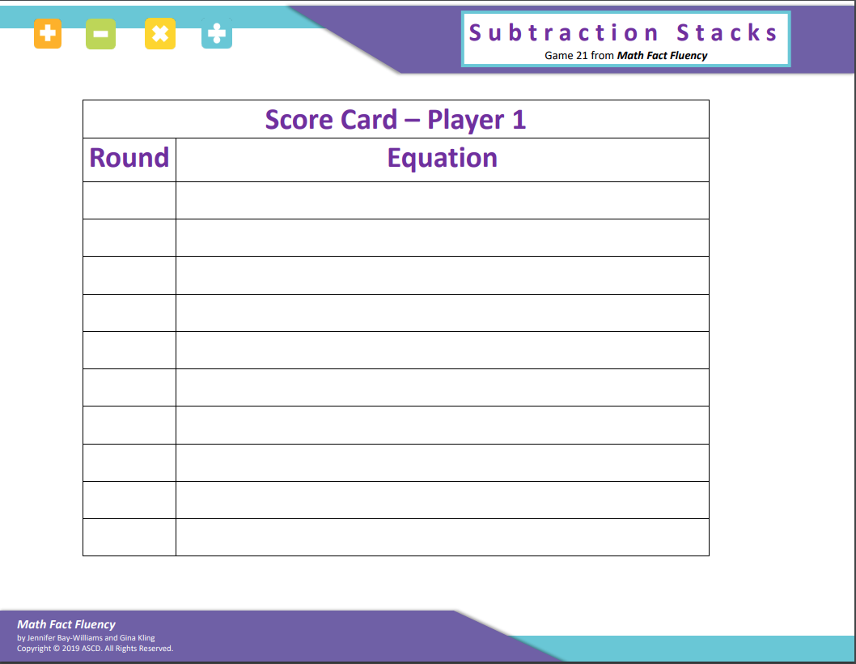
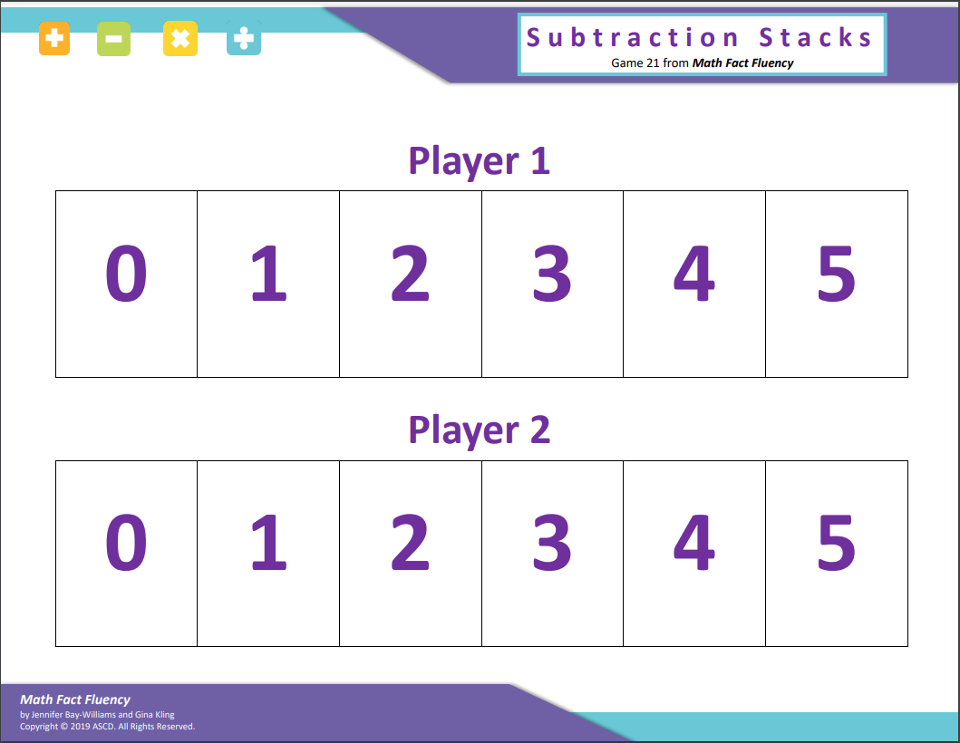
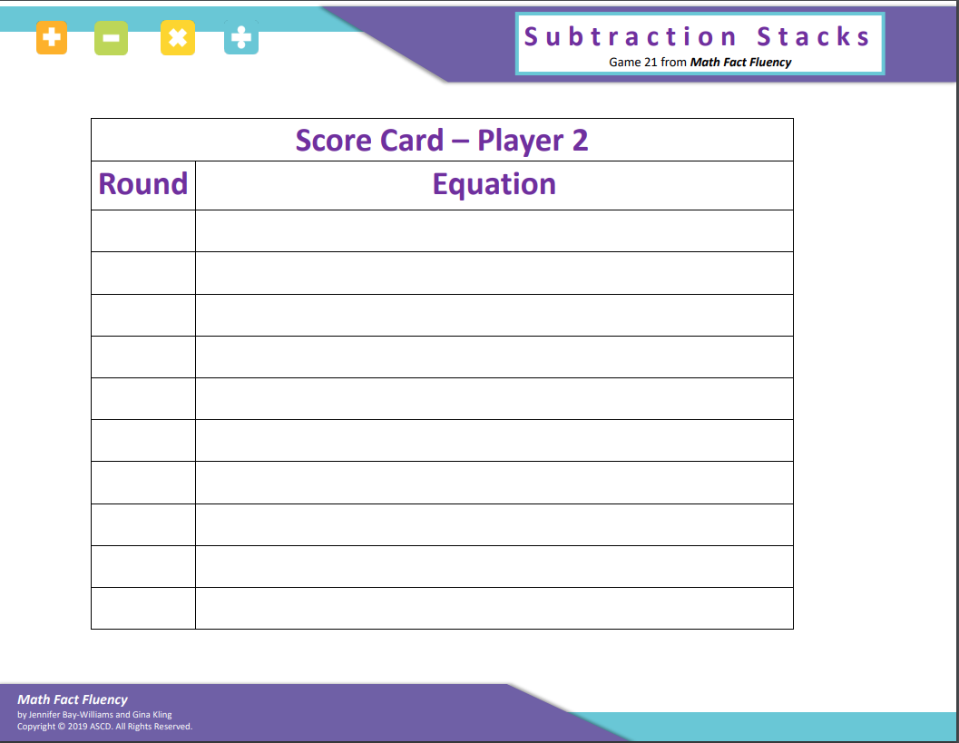

Subtraction Stacks 2-4 players
How to Play:
- Each player counts out 10 counters.
- Each player places the 10 counters on his/her Subtraction Stacks Game Card wherever they want to place them. Not every number has to have counters and multiple counters may be stacked on top of each other. (See example below)
- Player 1 rolls both dice and finds the difference between the two numbers. Player 1 explains the thinking strategy used to find the answer.
- All members of the group determine if the answer is correct.
- Player 1 removes a counter from the stack on his/her game card corresponding to the difference and records the equation on the recording sheet.
- If the player has no counters on that stack, nothing is removed.
- Repeat all steps for Players 2-4.
- The player that removes all the counters from his/ her game card first is the winner.
Game in Action:
- Example: A student has rolled a 6 and a 2. The difference between the two numbers is 4. The player removes a counter from the 4 stack. (If the player had nothing in the 4 stack, nothing would be removed and it would be the next players turn.)

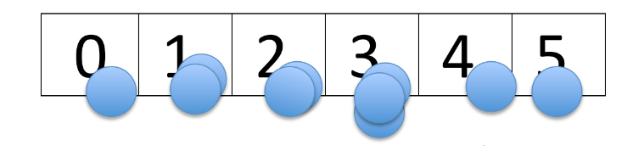
Possible Variations:
- Change to sums (use cards with higher numbers).
- Use more counters.
- Extend Subtraction Stacks game board to 9 or 11. Use 12- or 10- sided dice and give more counters to each player.

