Using Lucky 13 for Math Fact Fluency:
- Derived Fact Strategy Game for Addition
- Targeted skill: Sums within 20 (and differences from 13)
- Games provide an important venue for practicing strategies and encourages students to move from phase 2 to phase 3 with addition facts.
- Playing games gives students practice not just in using a strategy but also in choosing a strategy.
- Encouraging strategy use can be facilitated through group discussion of strategies before and after game play.
- Near Doubles, Making 10, and Pretend a Ten are accessible, commonly used, and powerful strategies students may use during Lucky 13.
About Games and Math Fact Fluency:
Games are fun. But, more importantly, games are effective ways to support learning. Games provide opportunities for:
- low-stress practice of (1) facts and (2) strategies (both outcomes are critical to math beyond the basic facts!).
- think aloud, an effective learning strategy. Therefore, students should develop the habit of verbalizing their mathematical thinking out loud.
- student listening and learning from peers. Therefore, discussing strategies before and after playing allows students opportunities to learn from each other.
- teachers to formatively assess and plan instruction. Therefore, at times, use an observation tool to record how students are progressing.
Effective math fact fluency games remove time pressure and allow students time to think. That means no time component. Each player has their own cards or dice to roll, so they are not racing each other. Scoring is de-emphasized. Thinking strategies are front and center.
Lucky 13 2-4 players
Materials: one deck of numeral cards or playing cards with kings and jacks removed (ace = 1, queen = 0), student score card for each player (see below), pencil, calculator (optional)

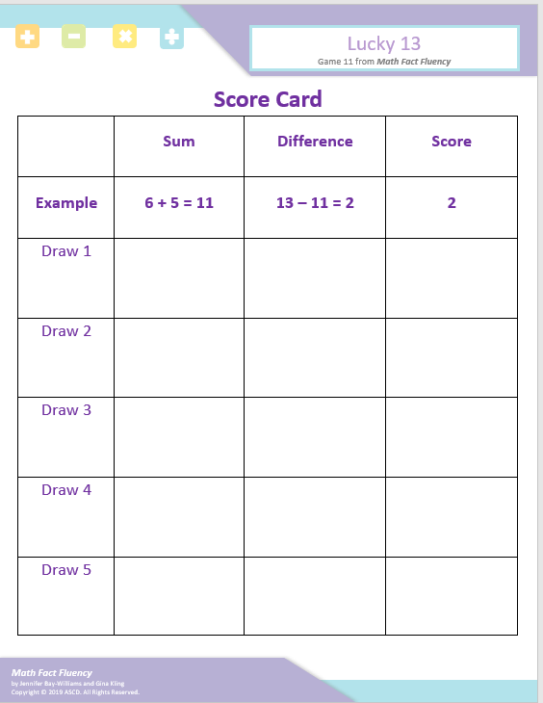
Lucky 13 2- 4 players
How to Play:
- Each player is dealt 4 cards face up.
- Each player picks two cards which, when added together, produces a sum as close to 13 as possible.
- Players record the sums on their score card.
- Players determine how far their sum is away from “Lucky 13” and record that difference on the score card. The player’s score for each round is the difference between the sum and 13.
- Players discard all their cards, and the dealer gives each player 4 new cards.
- Play repeats for five rounds.
- Players add their scores from each round.
- The player with the lowest score is the winner.

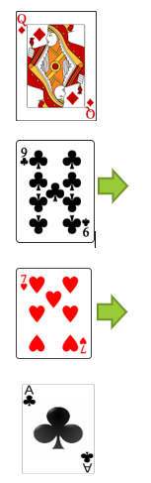
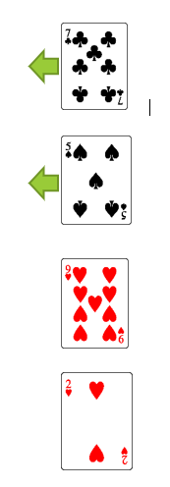
Game in Action:
I am going to choose the 7 and 5 because 7 plus 5 equals 12. My score is 1 because 12 is only 1 away from 13!
I am going to choose the 9 and 7. 9 plus 7 equals 16. My score for this round is 3 because 16 is 3 away from 13!

This Photo by Unknown Author is licensed under CC BY-SA

Possible Variations:
- Change the lucky number.
- Use any combination of cards to add to 13. (For example, a player may use all four of their cards)
- Change to subtraction with a lower lucky number (e.g., 3).
- Change to multiplication with a greater lucky number (e.g., 24).

