When are Near Squares useful? What do they look like?
It works great for the tricky 6s facts. Also 8s and 9s. Have a look!
Skylar was arranging polaroid photos on her wall. She wants to arrange them in 7 groups of 8. How many polaroid photos will she be able to fit?
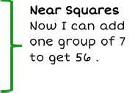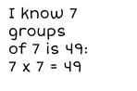

Students usually have an easier time memorizing their squares. Squares are very beneficial because they are close to some of the toughest multiplication facts (such as 7 × 8). Here, it is easier for students to add 7 to 49 since they know 7 × 7 rather than adding 7 groups of 8 (or 8 groups of 7) or skip counting.
If your child knows the square of 5 (5 × 5=25), they can use this to solve their 6 facts. Have a look at a fact that is commonly difficult for students: 5 × 6 or 6 × 5.
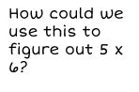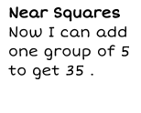

(see “fact #5” below)

Knowing squares and near squares can be helpful with solving problems with larger numbers mentally
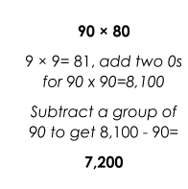
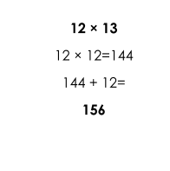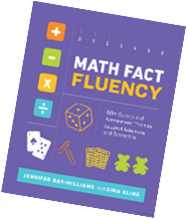– very useful! Examples:

Thank you for your support in developing fact fluency with your child!

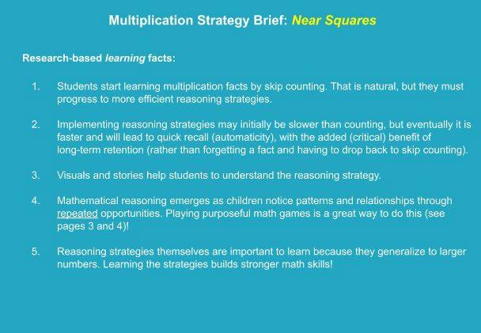

, Gam:,es for Near Squares and Learning Facts

16AIM E: Squares/Near Squares Bingo (2+ playe rs.)
M ate rials;
5 x 5 blaink grids/ bingo bo a rds fo r eac pl!IJYM
Bilflgo c hips/ oount e rs (e . g., pe n nte s/ c o in s. w ould wor k)
Dec k of pl ay i rn,g c ar cls 1-10 ,(ace "'1. queen "" oi
Howtll:I p'.l\ay
1 . Befu r e be gi n111ine; tine ga flllle, be s1.1re to p o st a li s.t oft e s qu1a re ipro d 1.1cts : 0 , l., 4 , '9, 1 6 , 25 , 36 , 4 9, 64 , 81., and
1 00 .

Z. Pl .n; CQPY th e r,iu1m lbers int o tlneir ga flllles b o.;i rd 5,, Some nurn b r5, wi II be re pe are ,d a nd 111ot a ll n1.1mben;
mi!€d to b@ t.1s@ d.
- Parent ,(or desienated leader ) dr.a ws .;i card from the deck. Pl aye rs w illl .sq1.1are that 11u mb er a cl cover their
ans we r on t he ir bo aird .

- Playe ,rs cover on S¢1LJa,r e at a tiime Jorily Olile chip cao be p,llaced ancil chiips al'lliot lbe moved orice they've been
place d j.

5_ Tti'ie fl rs t p lay,er 'l!IO geit fr,.,e in a, row ,[hor i ro n 'l:alfy, ve r lc:all y, o r d i a,gon ally) wins;_

Gam,e : Fix,ed F.crcto,r- War ,(Game 32, p, 88 , Math Pa ct Pluency}(2 pllayen ;.j

Ma tteriia1ls:
•

l),eck o f ca rds, 'With t::iirn g s a nd Ja cks re m o ve d ..Q ue e rns "' 10 ; Ace s ., 1.

How to Play:
l. Fin d .;i 6 in th@ de ck, m d p la o @ irl: betw@@n th@ two pla y @rs {or 7 or S) fac.e up. Th.at nu m b@r is th!!: f i:x@d
factor.

2. l) eal t h@ rns t of t he cardis. ,f! q u alt y, facf! down _

3, Eaclh pl ayer t a,ke.s. a t 1.1rn to f li p over the t op card of his/, h er pile of cards. The pfaiyer m1.1st st a;t e tihe
p rodu ct of t hle " f ixed " factor ca rd ;an d the caiird t lney fli p p ed, an d shaire how they know (see exa11rnple
b@lo w ) _

4 . The pla yer wiho cor rect ly-st ait es tlhe gre-at er pro duct in tlhe ro urnd gets both pla1,1er s.' cards- (The Mm i d dle n fii x,e d f act or card stays .}

S, ff t here is ai ti e, a uwar isded.a,r ed, and pl.aye r s re pea t the p ro c..es.s., w it h tlhe winr1e r t akir111: a ll p ja ye d
ca rd s _

6 , The pla yer wlth the mo.s,t cards wins when time is 11 .1p.

More ways to pl!a y: Use d iffe r@ nt Fi xed h cto rs {12 .g .,. 9, ) _ Pla y Factor Wa.r - o f ix12d h ct o r , each pltaye r d r a w s 2
car ds. Play with additi on, to o ! (fl 'x,er:I Adr:lem:J War or Addend War )
- • •
- ♦ ♦ g

Fiixe d F acto r Card :
does mot ,cha n ge

