Weekly Assignment 10 – Review for Exam 3
- Given a function f represented by the graph below
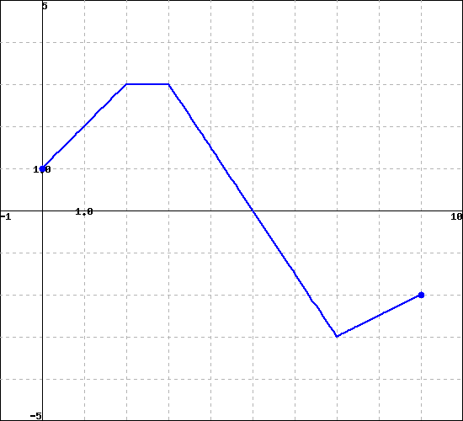
Find the following
  - $\int_{2}^{3}{f\left(x\right)dx}$
  - $\int_{0}^{9}{f\left(x\right)dx}$

- For each of the following, find the area under f over the indicated interval:
  - ${f\left(x\right)=12x}^{5}+\sqrt{x}+3$ on the interval [0, 1]

  - $f\left(x\right)=2\cos\left(x\right)+3^{x}$ on interval [1,3]

- Given that $F\left(x\right)=\int_{1}^{x}{f\left(t\right)dt}$, find a forula for F, which includes the value of the constant given that $f\left(x\right)={6x}^{2}+12x$
- Fill in the following table (slope on LHS is fine) given that F’(x) = f(x):
x | 1 | 4 | 7
f(x) | 2 | -3 | Not needed
F(x) | 5

- Given the following graph of y = f(x), let $F\left(x\right)=\int_{0}^{x}{f\left(t\right)dt}$ on the interval [0,2]. Complete the following:
- Draw a numberline approximating where F is pos, neg or zero,
- Draw a numberline labeling the signs (+,-,0) of F’ and F’’
- Sketch a rough graph of y = F(x) on the given interval

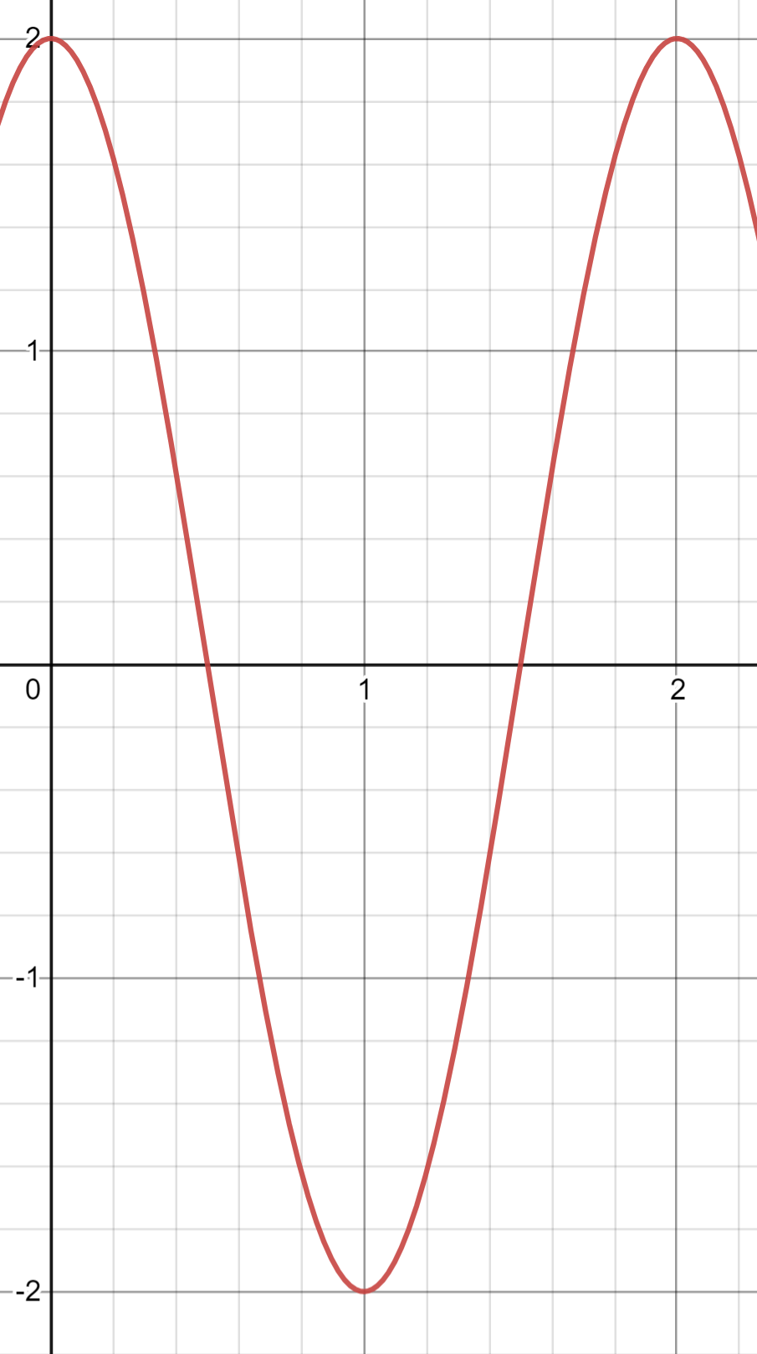I
- Evaluate the following:
  - $\int{\cos\left(3x+2\right)dx}$
  - $\int{x^{2}{(x^{3}+1)}^{5}dx}$
  - $\int_{0}^{1}{{x^{2}exp(x}^{3})dx}$
  - $\int{x\sqrt{x+4}dx}$

- We wish to use Riemann sums to find the length of the curve $f\left(x\right)=x^{3}$ from x =1 to x = 5 using the Left-Hand Side Rule (LHS) with 2 divisions.
  - Sketch the graph y = f(x) and draw the tangent line segments you will use to approximate the length labeling the point used, the horizontal and the vertical distance for each division.

  - Fill in the following table numerically
Division | x-value used | Horizontal distance | Vertical Distance | Length of curve
1
2

  - Fill in the same table using $x_{i}$ and$∆x$
Division | x-value used | Horizontal distance | Vertical Distance | Length of curve
1
2

  - Express the approximation of the total length as a numeric sum.

  - Express the approximation of the total length as a symbolic sum.

  - Convert the symbolic sum in part e to a Riemann Sum in the form $\sum_{i=1}^{n}{…}∆x$

  - Take the appropriate limit to express the exact length of the curve as an integral. (No need to evaluate)
- We wish to use Riemann sums with cylinders to approximate the mass of a concrete cone with base radius = 6 m and a height of 3 m. The concrete is denser at the base than at the top due to settling and is given by $density =\left(2400-100x\right)\frac{kg}{m^{3}}$ where x is the distance from the base of the cone. We are looking for the mass of the pyramid.
- Sketch the cone and, divide it into n divisions so that the density is approximately constant for each division.

- Draw a representative division: This is representative of the i^{th} division, where i goes from 1 to n. Express the approximate mass for this division in terms of $x_{i}$ and$∆x$

- Express an approximation of the total mass of the cone in the form $\sum_{i=1}^{n}{…}∆x$

- Take the limit of part c to find an integral expression representing the precise mass. You do not need to solve this integral.

