Solving Problems with Riemann Sums
- 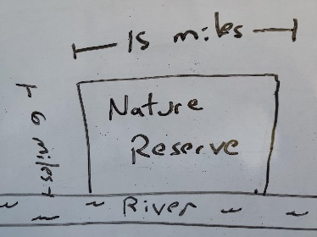 | One side of a 15 mile by 6-mile rectangular nature reserve borders a river (see left). The density of foxes decreases as the distance from a river increases and is given by $density of foxes=(10-x)\frac{foxes}{{mile}^{2}}$. Where x is the distance from the river in miles:

- In the diagram above, divide the Reserve into n divisions so that the density of foxes is approximately constant for each division.

- Draw a representative division: This is representative of the i^{th} division, where i goes from 1 to n. Express the approximate number of foxes for this division in terms of $x_{i}$ and$∆x$

- Express an approximation of the total number of foxes in the nature reserve in the form $\sum_{i=1}^{n}{…}∆x$

- Take the limit of part c to find an integral expression representing the precise number of foxes. You do not need to solve this integral.

- 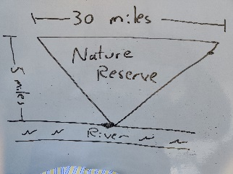 | A triangular rectangular nature reserve is next to a river (see left). The density of foxes decreases as the distance from a river increases and is given by $density of foxes=(20-2x)\frac{foxes}{{mile}^{2}}$. Where x is the distance from the river in miles. We are looking for the number of foxes that live in the reserve

- In the diagram above, divide the Reserve into n divisions so that the density of foxes is approximately constant for each division.

- Draw a representative division: This is representative of the i^{th} division, where i goes from 1 to n. Express the approximate number of foxes for this division in terms of $x_{i}$ and$∆x$

- Express an approximation of the total number of foxes in the nature reserve in the form $\sum_{i=1}^{n}{…}∆x$

- Take the limit of part c to find an integral expression representing the precise number of foxes. You do not need to solve this integral.

- 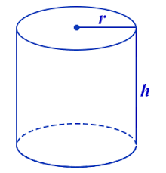 | The density of sludge in a cylindrical container (h = 3 m, r=2 m) is denser at the base than at the top and is given by $density =\left(1500-100x\right)\frac{kg}{m^{3}}$ where x is the distance from the base of the cylinder. We are looking for the mass of sludge in the container in meters. We are looking for the mass of the sludge filling the container.

- In the diagram above, divide the container into n divisions so that the density is approximately constant for each division.

- Draw a representative division: This is representative of the i^{th} division, where i goes from 1 to n. Express the approximate mass for this division in terms of $x_{i}$ and$∆x$

- Express an approximation of the total mass of sludge in the container in the form $\sum_{i=1}^{n}{…}∆x$

- Take the limit of part c to find an integral expression representing the precise mass. Solve this integral and indicate the precise mass.

- 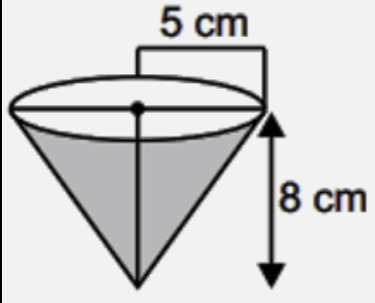 | There is more liight at the top than at the bottom of a vessel and the density of bacteria in the inverted cone vessel shown on the left is denser at the top than at the botto. The density is given by  $density=2000+30x^{3}\frac{organizms}{{cm}^{3}}$  where x is the distance from the base of the cylinder in cm. We are looking for the number of organisms in the vessel.

- In the diagram above, divide the container into n divisions so that the density is approximately constant for each division.

- Draw a representative division: This is representative of the i^{th} division, where i goes from 1 to n. Express the approximate number of organisms for this division in terms of $x_{i}$ and$∆x$

- Express an approximation of the total number of organisms in the container in the form $\sum_{i=1}^{n}{…}∆x$

- Take the limit of part c to find an integral expression representing the precise number of organisms. You do not need to solve this integral.

- We wish to use Riemann sums with cuboids to approximate the mass of a concrete pyramid with a square base of length = 16 m and a height of 4 m. The concrete is denser at the base than at the top due to settling and is given by $density =\left(2400-10x\right)\frac{kg}{m^{3}}$ where x is the distance from the base of the pyramid. We are looking for the mass of the pyramid.

- Sketch the pyramid and, divide it into n divisions so that the density is approximately constant for each division.

- Draw a representative division: This is representative of the i^{th} division, where i goes from 1 to n. Express the approximate mass for this division in terms of $x_{i}$ and$∆x$

- Express an approximation of the total mass of the pyramid in the form $\sum_{i=1}^{n}{…}∆x$

- Take the limit of part c to find an integral expression representing the precise mass. You do not need to solve this integral.

- 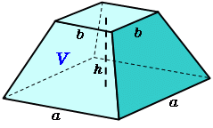 | An enormous block of hazelnut chocolate is being considered that has h =1 m, a = 2 m and b = 1 m with the shape to the left. The density of ground hazelnuts would be greater at the base than at the top and would be given by $density =\left(100-4x\right)\frac{kg}{m^{3}}$ where x is the distance from the base of the block. We are looking for the mass of hazelnuts needed to produce this block.

- In the diagram above, divide the container into n divisions so that the density of hazelnuts is approximately constant for each division.

- Draw a representative division: This is representative of the i^{th} division, where i goes from 1 to n. Express the approximate mass of hazelnuts for this division in terms of $x_{i}$ and$∆x$

- Express an approximation of the total mass of hazelnuts in the block in the form $\sum_{i=1}^{n}{…}∆x$

- Take the limit of part c to find an integral expression representing the precise mass. You do not need to solve this integral.

- A road is constructed with the form $y= x^{2},0≤x≤3$ with x = miles east of the city center and y = miles north of the city center. The density of buildings along the road decreases as you head east and is given by
$$density=10-2x\frac{buildings}{mile}$$

- Sketch the road and, divide it into n divisions so that the density of buildings is approximately constant for each division.

- Draw a representative division: This is representative of the i^{th} division, where i goes from 1 to n. Express the approximate number of buildings for this division in terms of $x_{i}$ and$∆x$

- Express an approximation of the total number of buildings in the form $\sum_{i=1}^{n}{…}∆x$

- Take the limit of part c to find an integral expression representing the precise number of buildings. You do not need to solve this integral.

- Optional
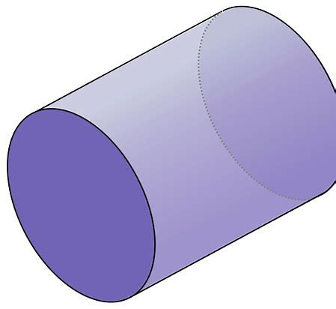 | A half-filled cylindrical container rests on its side. The density of sludge in the container (length = 10 m, radius=2 m) is denser at the top than at the bottom and is given by  $density =\left(1500-100x\right)\frac{kg}{m^{3}}$  where x is the distance from the ground. We are looking for the mass of sludge filling the container.

- In the diagram above, divide the container into n divisions so that the density is approximately constant for each division.

- Draw a representative division: This is representative of the i^{th} division, where i goes from 1 to n. Express the approximate mass for this division in terms of $x_{i}$ and$∆x$

- Express an approximation of the total mass of sludge in the container in the form $\sum_{i=1}^{n}{…}∆x$

- Take the limit of part c to find an integral expression representing the precise mass. Solve this integral and indicate the precise mass.

