6.2 Volumes

- We wish to use Riemann sums with cuboids to find the volume of a pyramid with a square base of sies = 12 m. and a height of 6 m. We will start with 3 divisions and will use the minimum height to approximate the volume of each division.
  - Sketch the pyramid, let x= height and find the relationship between x and the length of of the square’s sides at that height.

  - Fill in the following table numerically
Division | x-value used | Width of square | Height | Volume
1
2
3

  - Fill in the same table using $x_{i}$ and$∆x$
Division | x-value used | Width of square | Height | Volume
1
2
3
  - Express the approximation of the total volume as a numeric sum.

  - Express the approximation of the total volume as a symbolic sum.

  - Convert the symbolic sum in part f to a Riemann Sum in the form $\sum_{i=1}^{n}{…}∆x$

  - Take the limit of part 4 to find an integral expression representing the precise volume. Solve this integral to find the precise volume.
- We wish to use Riemann sums with cuboids to find the volume of a pyramid with a rectangular base of width 8, length 16 m. and height 4 m.
  - Divisions: Sketch the pyramid, let x equal the height of the pyramid and find the relationship between x and the length and the width of the rectangle at that value.

  - For Every division: Express the volume of the i^{th} division in terms of $x_{i}$ and$∆x$

  - Sum: Express an approximation of the total volume in the form $\sum_{i=1}^{n}{…}∆x$

  - Limit: Take the limit to find an integral expression representing the precise volume. Solve this integral to find the precise volume.

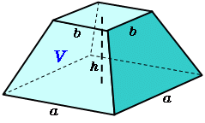 | - Given the truncated pyramid to the left with a = 8 m, b = 4 m and h = 2 m. Find the volume delineating the 4 steps:  - Divisions  - For each division  - Sum  - Limit

- We wish to use Riemann sums with cylinders to find the volume of a circular cone with a base of of radius 12 m. and a height of 4 m. We will start with 2 divisions and will use the minimum height to approximate the volume of each division.
  - Sketch the cone, let x= height and find the relationship between x and the radius of the circle at that height.

  - Fill in the following table numerically
Division | x-value used | radius | Height | Volume
1
2

  - Fill in the same table using $x_{i}$ and$∆x$

Division | x-value used | radius | Height | Volume
1
2

  - Express athe approximation of the total volume as a numeric sum.

  - Express athe approximation of the total volume as a symbolic sum.

  - Convert the symbolic sum in part e to a Riemann Sum in the form $\sum_{i=1}^{n}{…}∆x$

  - Take the limit of part 4 to find an integral expression representing the precise volume. Solve this integral to find the precise volume

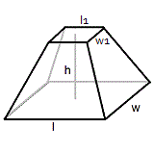 | - Given the truncated pyramid to the left with l = 12 m, w = 6 m, l2=6 m, w2 = 3 m and h = 3 m. Find the volume delineating the 4 steps:  - Divisions  - For each division  - Sum  - Limit

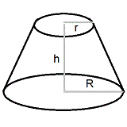 | - Given the frustrum to the left with r = 4 m, R = 24 m and h = 5 m. Find the volume delineating the 4 steps:  - Divisions  - For each division  - Sum  - Limit

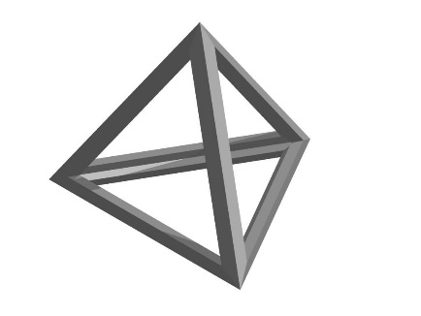 | - Optional: Given the tetrahedron to the left with the distance between all vertices equal to 6 m. Find the volume delineating the 4 steps:  - Divisions  - For each division  - Sum  - Limit

