Weekly Asignment 9

  - Given $F\left(x\right)=\int_{-1}^{x}{f\left(t\right)dt}$ and find the formula for F(x) that includes the value of the constant:given $f\left(x\right)=3x^{2}+2x+1$

  - Given $F\left(x\right)=\int_{0}^{x}{f\left(t\right)dt}$ and find the formula for F(x) that includes the value of the constant:given that $f\left(x\right)=e^{x}-sin(x)$

- Fill in the following tables (Using the left hand slope is fine)

x | -2 | 1 | 4 | 11
f(x) | -2 | 1 | 3 | -2
F(x) | 5

x | 0 | 5 | 10 | 15
f(x) | 2 | -1 | 4 | -3
F(x) | 5

- Given the following graphs of y = f(x), let $F\left(x\right)=\int_{0}^{x}{f\left(t\right)dt}$ and complete the following:
- Draw a numberline approximating where F is pos, neg or zero,
- Draw a numberline labeling the signs (+,-,0) of F’ and F’’
- Sketch a rough graph of y = F(x) on the given interval

    - Interval [0,2]
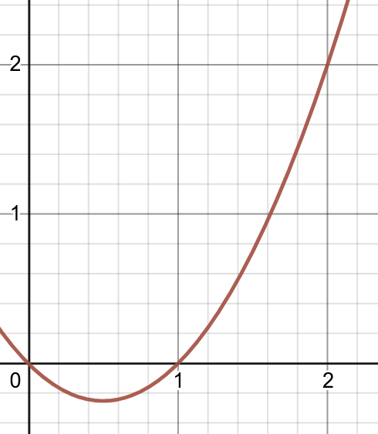I

    - nterval [0,3]
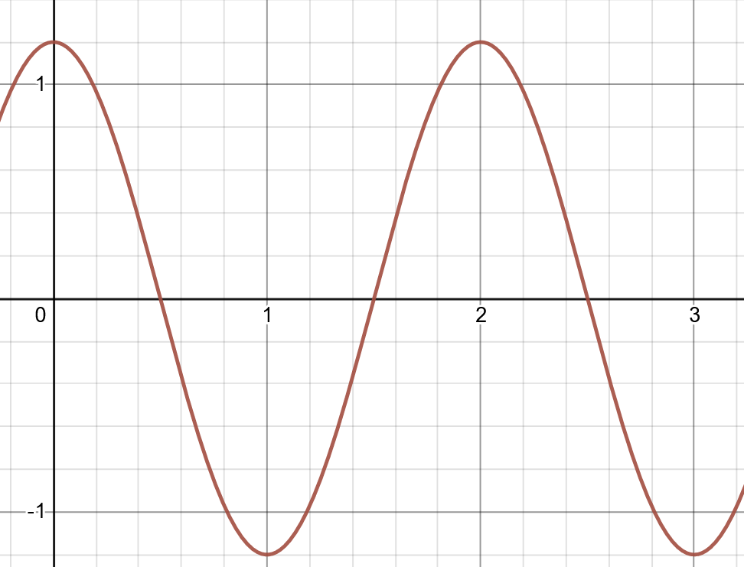

    - Interval [0,5]
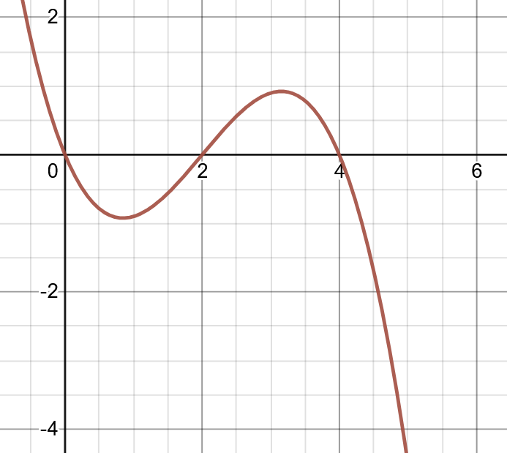

- Evaluate the following:
  - $\int{\sin\left(3x\right)dx}$
  - $∫e^{2x+1}dx$
  - $\int_{2}^{3}{\frac{1}{xln(x)}dx}$
  - $\int{x{(x^{2}+1)}^{10}dx}$
  - $\int_{0}^{1}{{x^{3}cos(x}^{4})dx}$
  - $\int{\tan\left(2x\right)dx}$
  - $\int{x{(x+2)}^{10}dx}$

