Finding F(x) with Different representations Name ____________________

* 1. Given and find the formula for *F(x) that includes the value of the constant*:given that $f\left(x\right)=2x+1$.
  2. Given $F\left(x\right)=\int_{0}^{x}{f\left(t\right)dt}$ and find the formula for *F(x) that includes the value of the constant*:given that $f\left(x\right)=sin(x)$.
  3. Given $F\left(x\right)=\int_{0}^{x}{f\left(t\right)dt}$ and find the formula for *F(x) that includes the value of the constant*:given that $f\left(x\right)=exp(x)$.

1. Fill in the following tables (Using the left hand slope is fine)

|  |  |  |  |  |
| --- | --- | --- | --- | --- |
| *x* | 2 | 5 | 8 | 11 |
| *f(x)* | 3 | -3 | 1 | -2 |
| *F(x)* | 1 |  |  |  |

|  |  |  |  |  |
| --- | --- | --- | --- | --- |
| *x* | 0 | 2 | 4 | 6 |
| *f(x)* | 2 | -3 | 4 | 1 |
| *F(x)* | 1 |  |  |  |

|  |  |  |  |  |
| --- | --- | --- | --- | --- |
| *x* | 1 | 5 | 9 | 13 |
| *f(x)* | 3 | -1 | 2 | -3 |
| *F(x)* | 2 |  |  |  |

1. Given the following graphs of *y = f(x),* let $F\left(x\right)=\int_{0}^{x}{f\left(t\right)dt}$ and complete the following:
2. Draw a numberline approximating where F is pos, neg or zero.
3. Draw a numberline labeling the signs (+,-,0) of F’ and F’’,
4. Sketch a rough graph of *y = F(x)* on the given interval.

Interval [0,3]

* + 1. Interval [0,3]

I

* + 1. nterval [0,10]

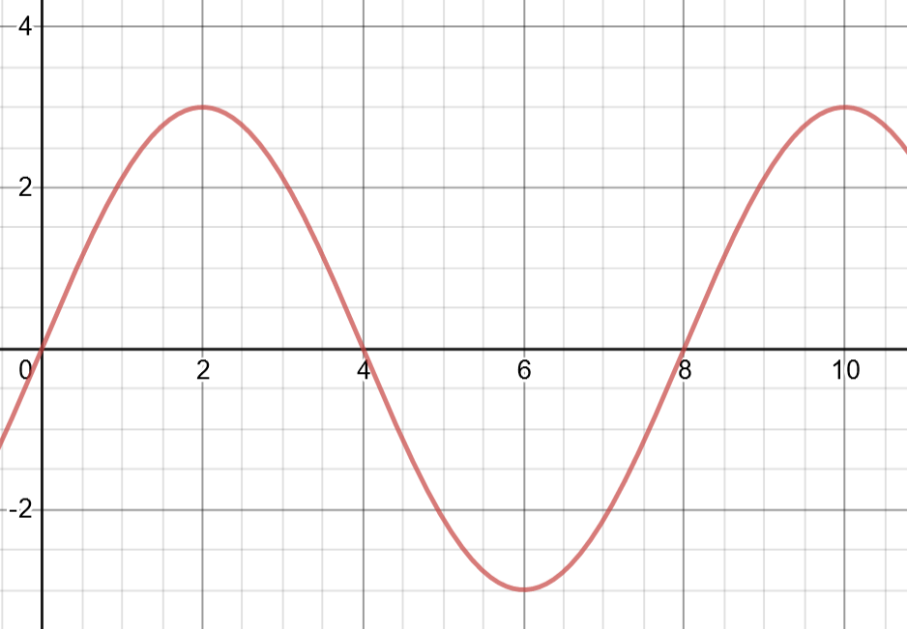

* + 1. Interval [0,6]

