Weekly Assignment – Ways to Find the Area Under a Curave Name_____________________

- Given functions f and g represented by the graphs below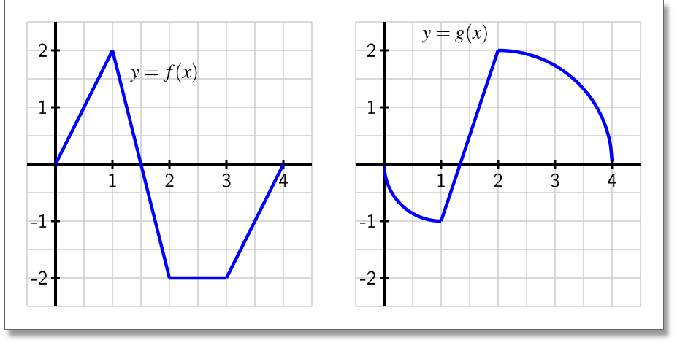
Find the following
  - $\int_{0}^{4}{f\left(x\right)dx}$

  - $\int_{1}^{3}{f\left(x\right)dx}$

  - $\int_{2}^{4}{2g\left(x\right)-3f\left(x\right)dx}$

- For each of the following, find the area under f over the indicated interval:
  - ${f\left(x\right)=6x}^{2}+2x+3$ on the interval [0, 2]

  - $f\left(x\right)=2\cos\left(x\right)+3\sin\left(x\right)-2e^{x}$ on the interval [1,2]

  - $f\left(x\right)=\sqrt{4x}+\frac{3}{x^{3}}+\frac{x^{2}+2x}{x}$ on the interval [1, 4]

  - $f\left(x\right)={3*2}^{x}+\frac{4}{x}$ on the interval [1,3]

- We wish to use Riemann sums to find the area under the curve $f\left(x\right)=x^{2}-2x$ from x = -1 to x = 5 using the Midpoint Rule with 3 divisions.
- Sketch the graph y = f(x) and draw the rectangles you will use to approximate the area labeling (x,y) at the RHS of each division as well as $x_{i}$ and$∆x$.

- Fill in the following table numerically
Division | x-value used | Width | Height | Area
1
2
3

- Fill in the same table using $x_{i}$ and$∆x$
Division | x-value used | Width | Height | Area
1
2
3

- Express athe approximation of the total area as a numeric sum.

- Express athe approximation of the total area as a symbolic sum.

- Convert the symbolic sum in part e to a Riemann Sum in the form
$\sum{…∆x}$

- Take the appropriate limit of the Riemann sum that will convert $\sum{…∆x}$ to the precise area in the form $\int{…dx}$ and evaluate the integral to find the precise area.

