Lab – Using derivatives for graphs
- For the following diagrams with signs for f’ and f’’, draw a possible graph for f
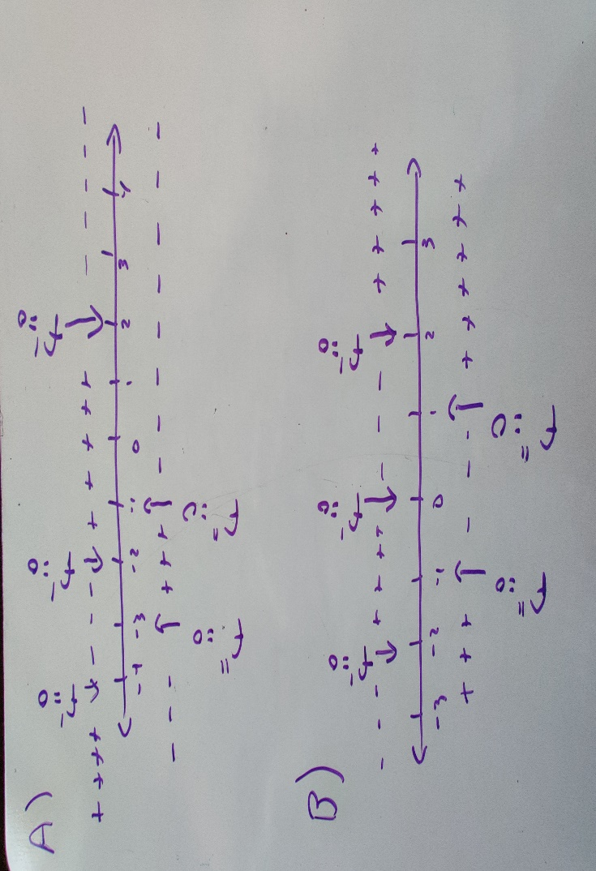
- For the functions A-F below,
- Find the formula of f’ and f’’.
- Find the values of x where f’ and f’’ are equal to zero.
- Create a numberline with the signs of f’ and f’’ as done in problem 1
- Find the coordinates of the points of inflection, local maxima and minima
- Draw the graph of f labeling max/min/pts of inflection. (feel free to check with Desmos)

- $f\left(x\right)=\frac{x^{3}}{3}-\frac{x^{2}}{2}-12x$
- $f\left(x\right)=\frac{1}{x}$
- $f\left(x\right)=x^{3}+{3x}^{2}-24x$
- $f\left(x\right)=sin(x)-cos(x)$ on the interval [0,2pi]
- $f\left(x\right)=\frac{x^{4}}{4}-{2x}^{2}$
- $f\left(x\right)=\frac{x}{e^{2x}}$ (Hint: easier to rewrite as a product)
- Optional: $f\left(x\right)=cot(x)$ on the interval [0,2pi]

