Section 3.3 - Optimization
- For the following graph of f on the interval [1,5]:
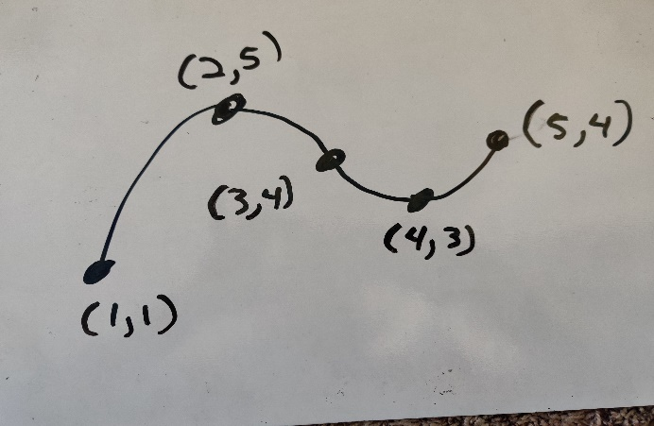
  - Identify the value of x and y at
    - The endpoints,
    - The local maxima,
    - The local minima,
    - The points of inflection.
  - Identify the value of x and y at the global max (largest value of y on the interval) and determine whether it occurs at an endpoint or a local max.
  - Identify the value of x and y at the global min (smallest value of y on the interval) and determine whether it occurs at an endpoint or a local min.
- For the following graph of f on the interval [1,5]
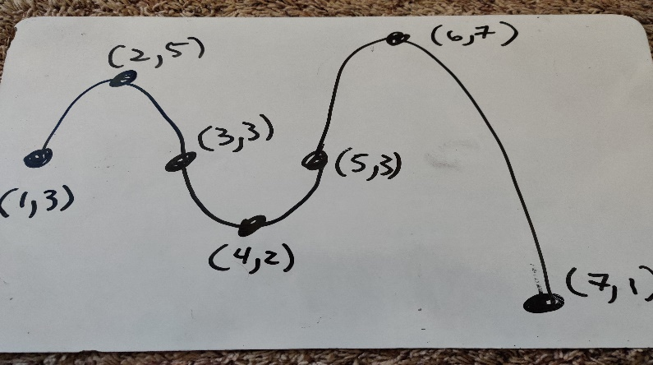
  - Identify the value of x and y at
    - The endpoints,
    - The local maxima,
    - The local minima,
    - The points of inflection.
  - Identify the value of x and y at the global max (largest value of y on the interval) and determine whether it occurs at an endpoint or a local max.
  - Identify the value of x and y at the global min (smallest value of y on the interval) and determine whether it occurs at an endpoint or a local min.
- For the functions A-D below:
- Find the formula of f’ and f’’.
- Find the values of x where f’ and f’’ are equal to zero.
- Create a numberline with the signs of f’ and f’’ as done in class
- Find the points of inflection, local maxima and minima
- Find the value of f at the interval endpoints
- Determine the global max and global min
- Draw the graph of f on the interval labeling the local and global max/min as well as the pts of inflection. (feel free to check with Desmos)

- $f\left(x\right)=x^{3}-`12x+1$ on the interval [-4, 3]
- $f\left(x\right)=\sin\left(x\right)+cos⁡(x)$ on [0,2pi]
- $f\left(x\right)=x^{3}-{3x}^{2}-9x$ on [-2,4]
- $f\left(x\right)=xe^{-0.5x}$ on [-1,5]

- The error function for a positioning algorithm is given by

$$f\left(h\right)=\frac{h^{3}}{3}-2h^{2}+3h+1$$

where h is the distance of the camera from an object and f(h) is the error in the position that the algorithm returns. Given that $0<h≤4$
- What is the optimal distance for the camera?
- What is the worst possible distance to place the camera?

