Lab – Using Derivatives to graph functions
- For the graphs A-B below,
- Find the values of x where f’ and f’’ are equal to zero.
- Create a numberline with the signs of f’ and f’’ clearly indicating the precise values of x where these are zero.
- Find the values of x where there are pts of inflection, local maxima and local minima

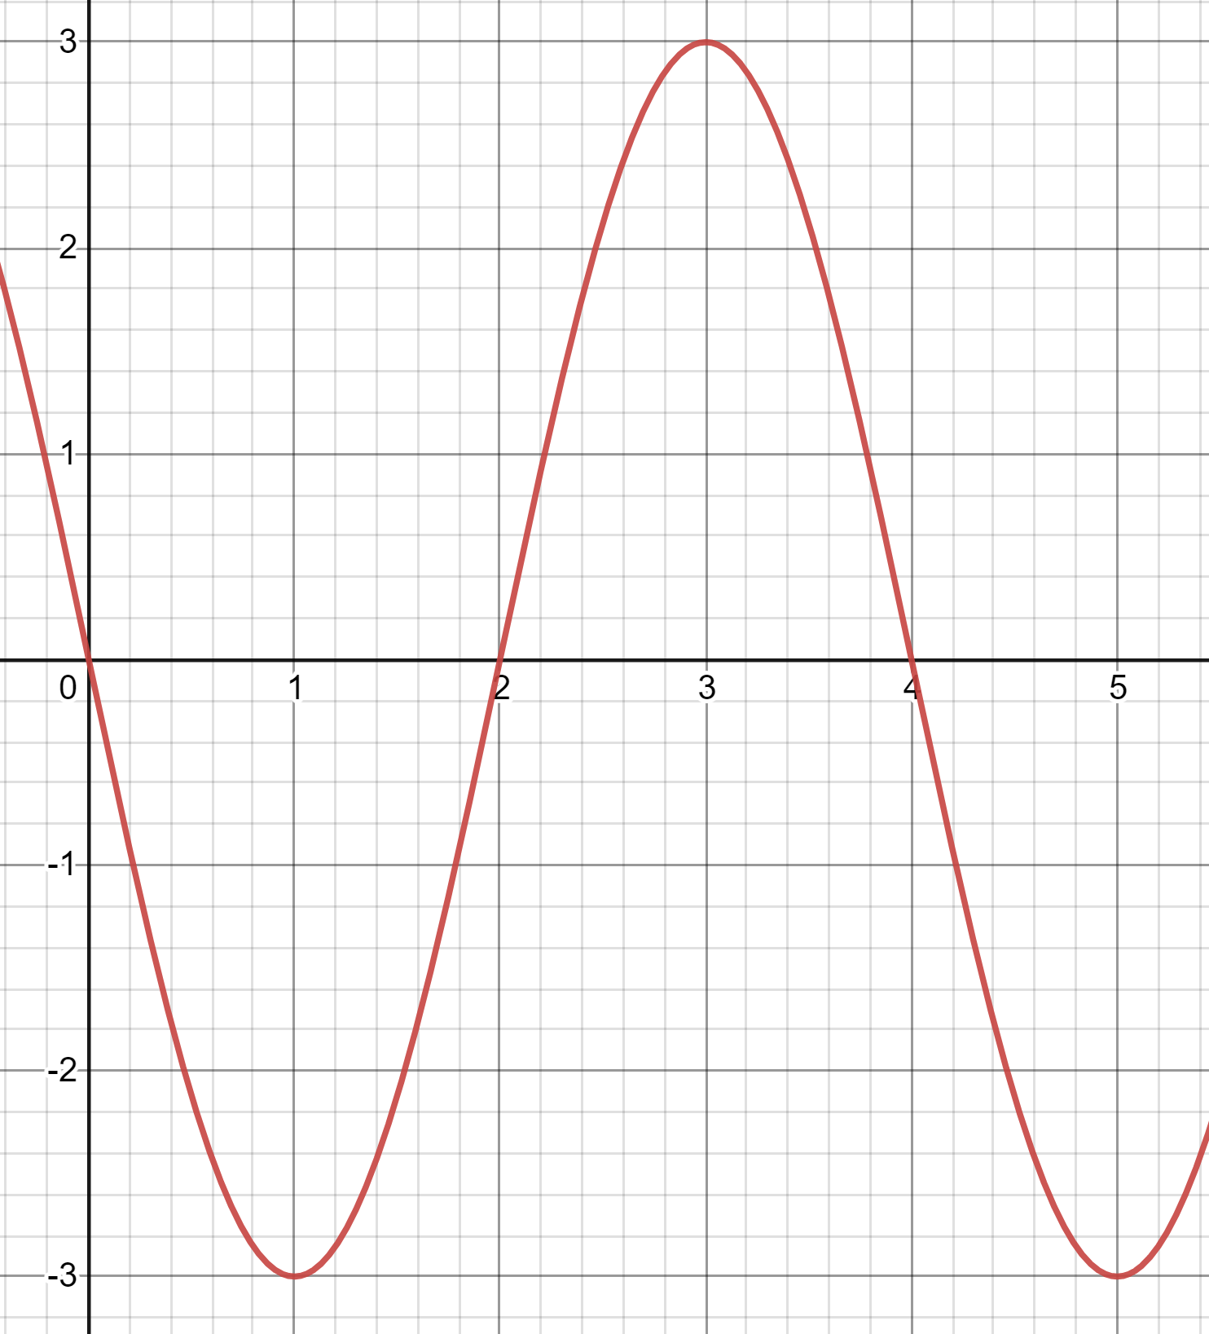
- S
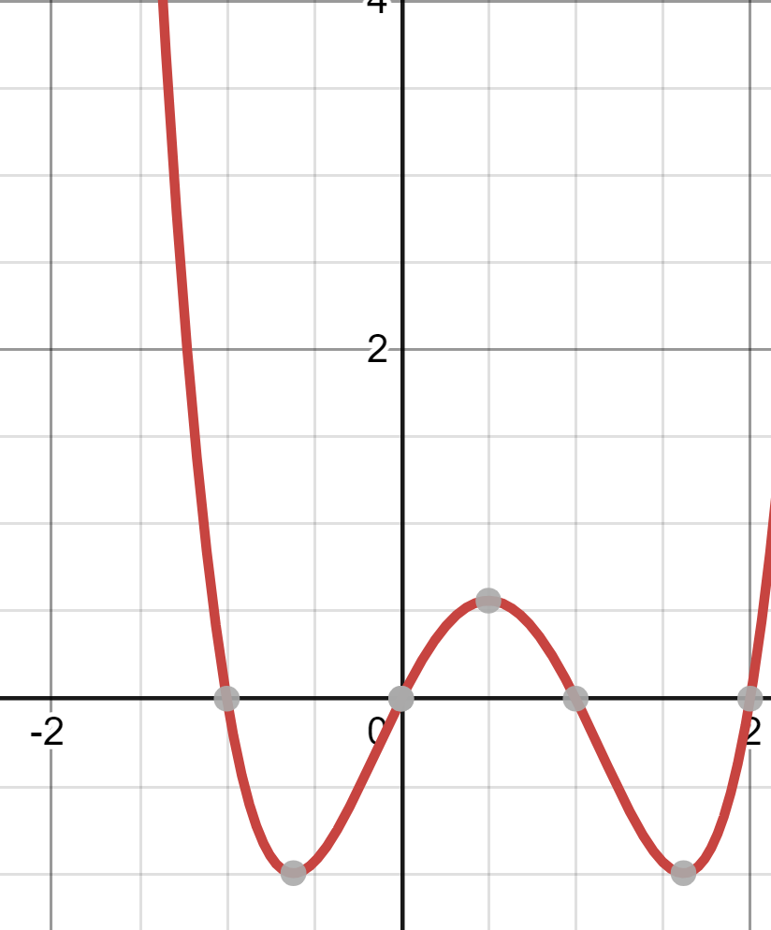

- For the numberlines A-B below, draw the graph of f on the interval labeling the x values of the local maxima, local minima and pts of inflection.

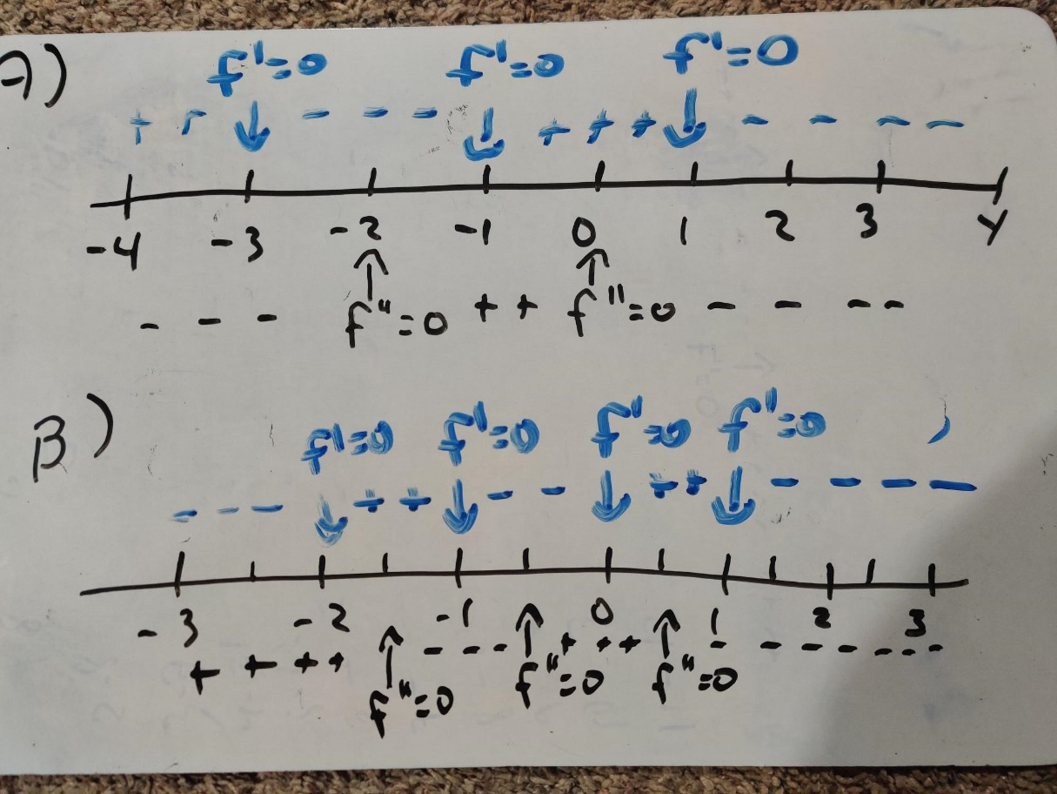
- For the functions A-D below,
- Find the formula of f’ and f’’.
- Find the values of x where f’ and f’’ are equal to zero.
- Create a numberline with the signs of f’ and f’’ as done in class
- Find the points of inflection, local maxima and minima
- Draw the graph of f on the interval labeling max/min/pts of inflection. (feel free to check with Desmos)

- $f\left(x\right)=x^{3}+{6x}^{2}+9x+1$ on the interval [-4, 1]

- $f\left(x\right)=\frac{x^{3}}{3}-4x+1$ on the interval [-3, 3]

- $f\left(x\right)=\frac{x^{4}}{2}-x^{2}+1$ on [-3,3]

- $f\left(x\right)=\cos\left(x\right)-sin(x)$ on [0,2pi]

