Weekly Assignment – Review for Exam 2
- Use the algebraic definition of a derivative (forward difference quotient) to demonstrate that the power rule $\frac{d}{dx}(x^{n})=nx^{n-1}$is true when
  - $n=-1$
  - $n=\frac{1}{2}$
- Use the algebraic definition of a derivative (forward difference quotient) to demonstrate that if $\lim_{h→0}{\frac{e^{h}-1}{h}=1}$ then $\frac{d}{dx}\left(e^{x}\right)=e^{x}$
- Use the algebraic definition of a derivative (forward difference quotient) to demonstrate that (Note: sum of angle formulas and the values of required limits will be provided on the exam):
  - If h(x) = sin(x) then h’(x) = cos(x)
  - If h(x) = cos(x) then h’(x) = -sin(x)
- Draw a diagram to justify geometrically that f(a + h) = f(a) + hf’(a). Make sure that your diagram includes the a, a+h, f(a), f(a+h), L(a+h), and most important the length associated with h*f’(a)
  - Use this result and the algebraic definition to justify the product and reciprocal rules.
- Use the reciprocal or quotient rules for derivatives to verify the following formulas for the derivatives of other trig functions:
  - If f(x) = tan(x) then $f'\left(x\right)=\sec^{2}(x)$
  - If f(x) = cot(x) then $f'\left(x\right)={-csc}^{2}(x)$
  - If f(x) = sec(x) then f’(x)= sec(x)tan(x)
  - If f(x) = csc(x) then f’(x)= -csc(x)cot(x)
- Use implicit Differentiation to justify the following derivatives showing all of your steps
  - $\frac{d}{dx}\left(ln\left(x\right)\right)=1/x$
  - $\frac{d}{dx}\left(log\left(x\right)\right)=1/(\ln\left(10\right)*x)$

- Find y’ for each of the following
  - $y=sin⁡(x)*2^{x}$
  - $y=\frac{⁡e^{x}}{ln\left(x\right)}$
  - $y=ln⁡(\sin\left(x\right))$
  - ${y=(4x+3)}^{23}*e^{2x+1}$
  - $\sin\left(x\right)+1={xy}^{2}$
  - $\ln\left(x+y\right)=y^{2}$

- Find the tangent line to $f(x)=e^{2x}$ when x = 0 and use it to approximate f(0.3).

- Given the graph of f shown below, sketch the graph of f’.

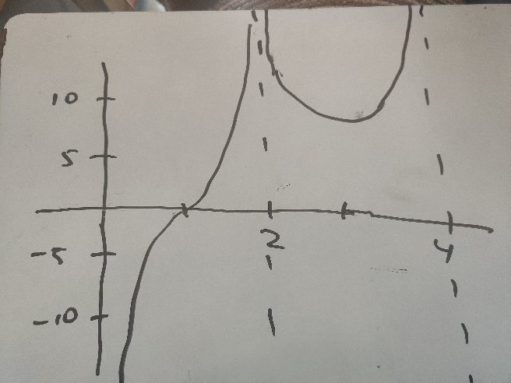

- For the functions A-B below,
- Find the formula of f’ and f’’.
- Find the values of x where f’ and f’’ are equal to zero.
- Create a numberline with the signs of f’ and f’’ as done in class
- Find the points of inflection, local and global maxima and minima
- Draw the graph of f on the interval labeling local and global max/min and pts of inflection. (feel free to check with Desmos)

- $f\left(x\right)=x^{4}-{2x}^{2}+1$ on [-2,2]
- $f\left(x\right)=2-cos⁡(x)-sin⁡(x)$ on [0,2pi]

