Weekly Assignment 6

1. Use implicit differentiation to find the derivative of the following:
$\frac{d}{dx}(ln\left(x\right)$

$\frac{d}{dx}(log\left(x\right))$

2. Find the derivatives of the following functions
$f\left(x\right)=sin⁡(3x)e^{x^{3}}$

$f\left(x\right)=ln(2x+3){*2}^{3x}$

$f\left(x\right)=\frac{\sqrt{2x+1}}{cos⁡(2x)}$

3. Use implicit differentiation to find y’ for the following:

4. For each of the following graphs of *f*, draw the graph of *f’:*

a. 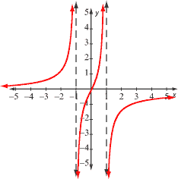

b. 