Weekly Assignment 5

- Product rule
  - Draw a diagram with an accomplanying explanation to justify that as h goes to zero, f(a+h) = f(a) + h*f’(a)

  - Use the results of part a and the algebraic definition to justify the product rule for $\frac{d}{dx}(f\left(x\right)*g\left(x\right))$

  - Reciprocal Rule: Use the previous problem and the algebraic definition to find $\frac{d}{dx}(\frac{1}{f(x)})$

- Quotient rule: Use the reciprocal rule and the product rule to find $\frac{d}{dx}(\frac{f(x)}{g(x)})$
- Use the reciprocal or quotient rules for derivatives to verify the following formulas for the derivatives of other trig functions:
  - If f(x) = tan(x) then $f'\left(x\right)=\sec^{2}(x)$
  - If f(x) = cot(x) then $f'\left(x\right)={-csc}^{2}(x)$
  - If f(x) = sec(x) then f’(x)= sec(x)tan(x)
  - If f(x) = csc(x) then f’(x)= -csc(x)cot(x)
- Given the following graphs of f, draw the graph of f’:
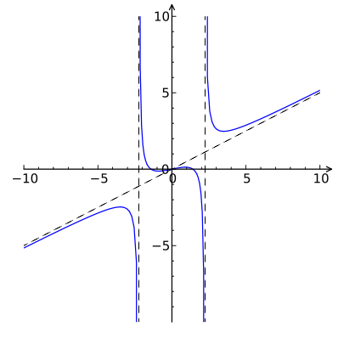 | 