Review Trigonometric Functions Name ______________
- Use https://www.geogebra.org/m/nv9vex3X to fill in the following Table with deci,als:
x degrees | 0 | 45 | 90 | 135 | 180 | 210 | 240 | 315 | 360 | 405
cos(x)
sin(x)
tan(x)
- Use the above table to plot y= cos(x) and y = sin(x) in the grids below
 |  | 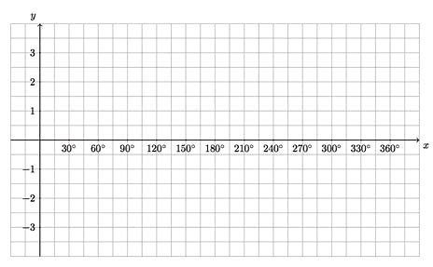
y = cos(x) | y = sin(x) | y = tan(x)

- Draw unit-circle diagrams to visualize and write down relationships between the following
sin(x), sin(180-x) | cos(x), cos(180-x) | tan(x), tan(180+x)
Unit circle diagram

Relationships

sin(x), sin(-x) | cos(x), cos(-x) | cos(x), cos(180+x)

- Fill in the following table associated with the unit circle to convert angle measure in degrees to angle measure in readians:
Angle measure in Degrees | 180 | 90 | 270 | 60 | 30 | 45 | 10 | 20 | 360
Associated Fraction of Circumference
Associated Length of Arc on U.C. in m.
Angle measure in radians
- Use https://www.geogebra.org/m/nv9vex3X to fill in the following Table with decimals:
x radians | 0 | $$\frac{π}{2}$$ | $$\frac{3π}{4}$$ | $$π$$ | $$\frac{5π}{4}$$ | $$\frac{3π}{2}$$ | $$\frac{7π}{4}$$ | $$2π$$
cos(x)
sin(x)
tan(x)
- Use the above table to plot y= cos(x), y = sin(x) and y = tan(x) below
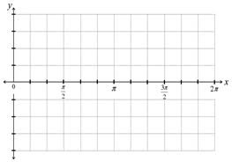  y = cos(x) | y = sin(x) | y = tan(x)

- Optional: Draw an appropriate diagram and explain why sin(90-x) = cos(x) and cos(90-x) = sin(x)

