Section 1.8 – The Tangent Line Approximation

1. Given that *f(x) = x3:*
   1. Find the formula for *f’(x)*.
   2. What do the the tangent line to f at *x=*1 and the function f have in common? Find the formula for,*y = L(x) ,* the tangent line to *f* at *x = 1*.
   3. Graph *y = f(x)* and *y = L(x)* using Desmos. Zoom in on the two functions near *x = 1.* Indicate the range of *x values* where you believe *L* will provide an effective approximation of *f* and take a screenshot to justify your estimate.
2. Given that *f* is represented by the following table:
   1. Fill in the missing row with the best possible approximation for *f’(x)*
   2. Using the best possible approximation of *f’(x)*, find the formula for the tangent line to *f* at the point (2,7). Call this function *L.*
   3. Use *L* to approximate *f(2.3)* and *f(6.3).* Give your thoughts on the accuracy of each of these two estimates. Is there a better estimate available for either of them?

|  |  |  |  |  |
| --- | --- | --- | --- | --- |
| *x* | 0 | 2 | 4 | 6 |
| *f(x)* | 4 | 7 | 12 | 19 |
| *f’(x)* |  |  |  |  |

1. Given that $y=fIx)=2x^{2}$, use the linear approximation to *f* at (-1, 2) to approximate the value of *f(-0.7).*
2. Given the following graph of *y = f(x)*
   1. Draw thte tangent line approximation to *f* at the point (2,3)
   2. Use the tangent line approximation at *x = 2* to estimate *f(2.4)*.

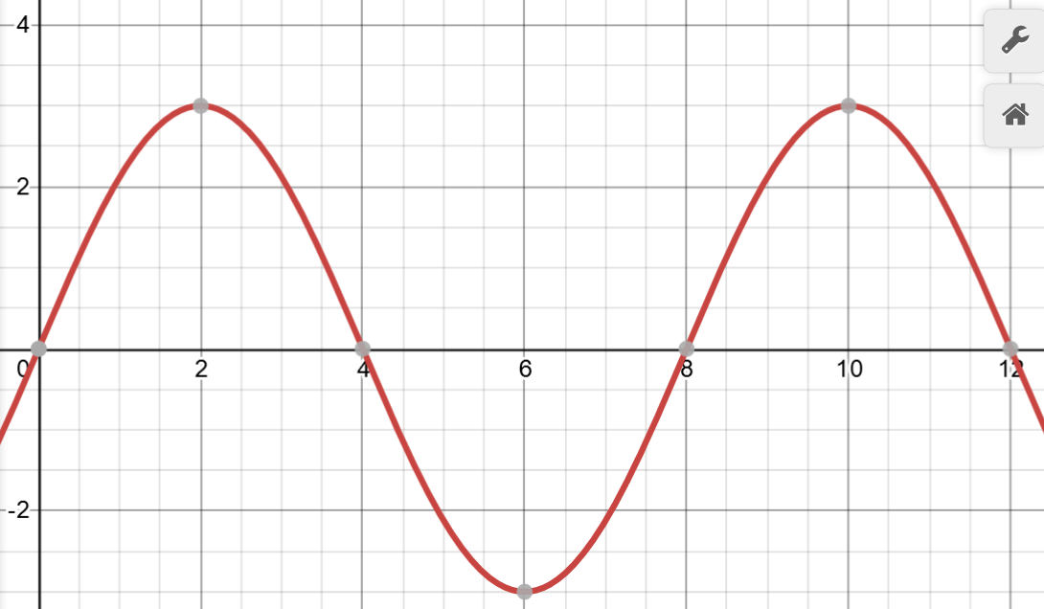

1. A function *f* is represented by the following table.
2. Fill in the table with the best approximation of *f’*
3. Use a tangent line approximation to find the best possible approximation of *f(0.23)*

|  |  |  |  |  |
| --- | --- | --- | --- | --- |
| *x* | 0.1 | 0.2 | 0.3 | 0.4 |
| *f(x)* | 1.1 | 0.7 | 1.5 | 1.3 |
| *f’(x)* |  |  |  |  |

1. The tangent line approximation for a function f at the point 1,3) is given by y *= 2x + 1*.
2. Draw the tangent line and a possible graph of *f* that is consistent with using this approximation.
3. Create a possible non-linear table for *f* that would be consistent with using this approximation.
4. Create a possible non-linear formula for *f* that would be consistent with using this approximation.