Section 1.6 – Second Order Derivatives

1. Given the following graph of *y = f(x)* fill in the following table.

|  |  |  |  |
| --- | --- | --- | --- |
|  | *f* | *f’* | *f’’* |
| Values (intervals) where negative |  |  |  |
| Values where equal to zero |  |  |  |
| Values (intervals) where positive |  |  |  |

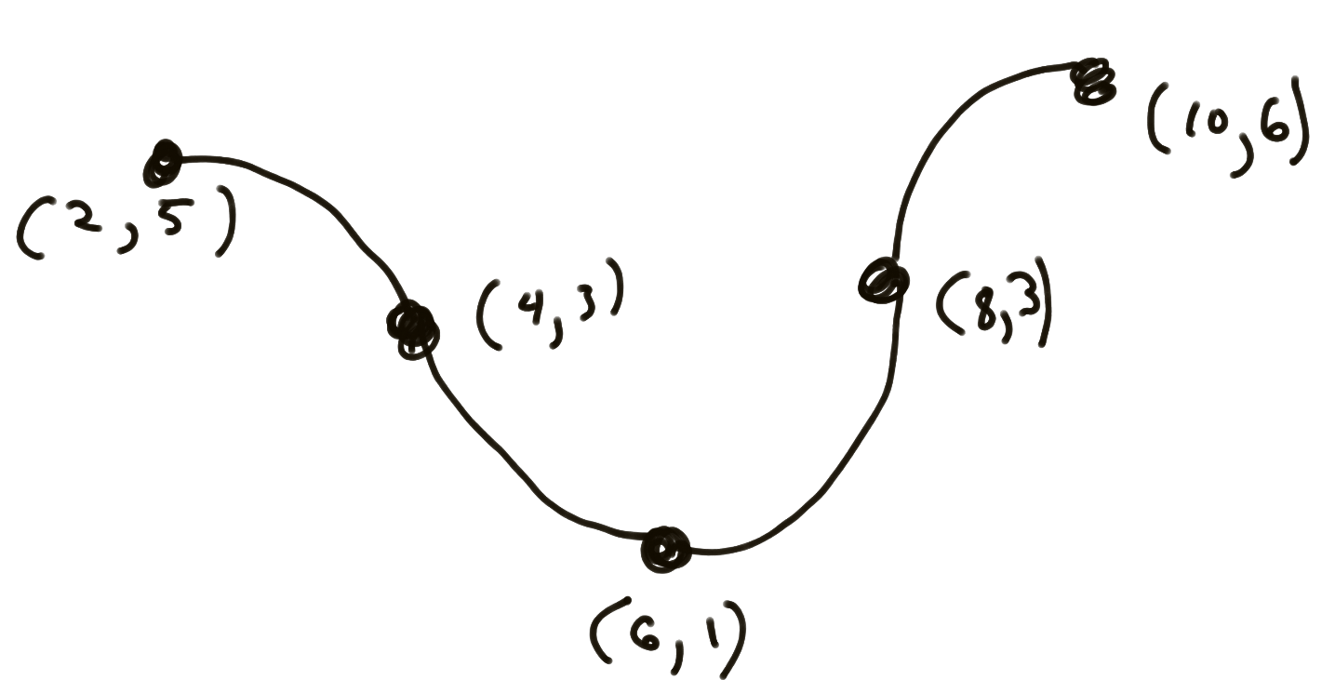

1. If *f* is represented by the following table, fill in the missing rows on the table with the best approximation:

|  |  |  |  |  |
| --- | --- | --- | --- | --- |
| *x* | 0 | 2 | 4 | 6 |
| *f(x)* | 4 | 6 | 7 | 6 |
| *f’(x)* |  |  |  |  |
| *f’’(x)* |  |  |  |  |

1. Given the following graph of *y = f(x)* fill in the following table and draw graphs of *f’* and *f’’.*

|  |  |  |  |
| --- | --- | --- | --- |
|  | *f* | *f’* | *f’’* |
| Values (intervals) where negative |  |  |  |
| Values where equal to zero |  |  |  |
| Values (intervals) where positive |  |  |  |

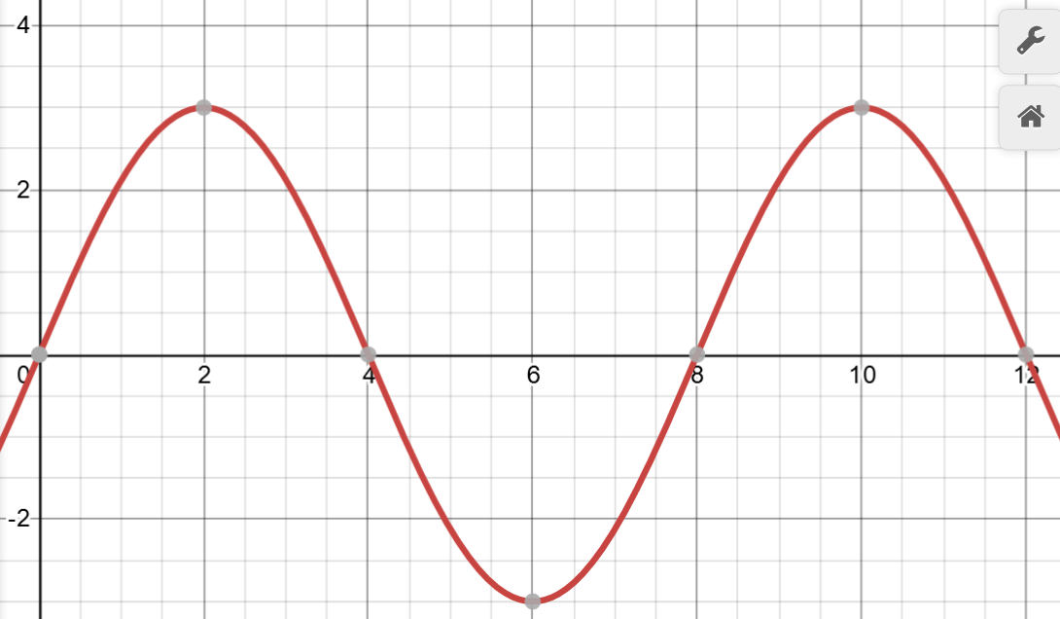

1. Given that $y=f(x)=x^{3}$, use the algebraic definition to find a formula for *y = f’(x)* and *y = f’’(x). Show all of your work!*
2. Given the following graph of *y = f(x),* fill in the following table and draw a graph of *f’* and *f’’*

|  |  |  |  |
| --- | --- | --- | --- |
|  | *f* | *f’* | *f’’* |
| Values (intervals) where negative |  |  |  |
| Values where equal to zero |  |  |  |
| Values (intervals) where positive |  |  |  |

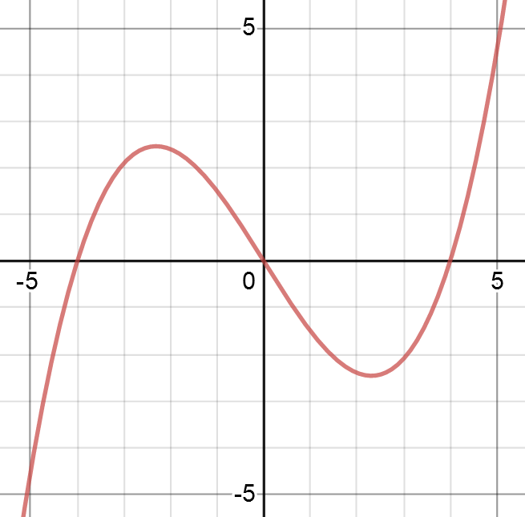

1. Optional: Draw a graph of *f* that is consistent with the following table

|  |  |  |
| --- | --- | --- |
|  | *f’* | *f’’* |
|  |  |  |
| Values (intervals) where negative | (-2,0), (4,6) | (2,6) |
| Values where equal to zero | x = 0, x = 4 | x = 2 |
| Values (intervals) where positive | (0,4) | (-2,2) |