Section 1.5 – More on Derivatives Name__________________
- A function f is represented by the following table.
  - Fill in the missing cells with the best possible approximation.
  - What are the units of f’(x)?
  - Describe a situation that could accompany this table.
  - If f’(a) = 0, what is the best guess for a?
x=days | 0 | 2 | 4 | 6
f(x)=height of water (meters) | 4 | 6 | 6 | 4
f’(x)

- The function f is represented by the following graph.
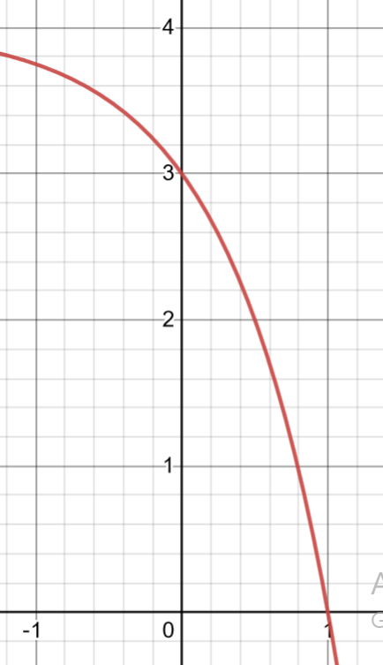 | Draw the tangent line to f at x = 0 and use it to approximate f’(0).  $f'(0)≈______$  If h = 1, for each of the following difference quotients, draw the line and approximate f’(0)  - Forward difference quotient or average slope on [0,0+h]  $f'(0)≈______$  - Backward difference quotient  Or average slope on [0-h,0]  $f'(0)≈______$  - Centered difference quotient  or average slope on [0-h,0+h]  $f'(0)≈______$  Which approximation is closest to the actual value of f’(0)

- Given that $y=fIx)=2x^{2}$,
  - Calculate f’(x) using the algebraic definition with the backward difference quotient, the forward difference quotient and the centered difference quotient.

  - Verify that they all give the same answer

  - Why would these calculations suggest that the central difference quotient works best?

- A function f is represented by the following table.
  - Fill in the missing cells with the best possible approximation.
  - What are the units of f’(x)?

  - What does f’ tell us about the situation?

x = weeks since Jan 1 | 0 | 1 | 2 | 3
f(x) =current Hospitalizations due to Covid | 600 | 1000 | 1200 | 1300
f’(x)

- The function f is represented by the following graph.
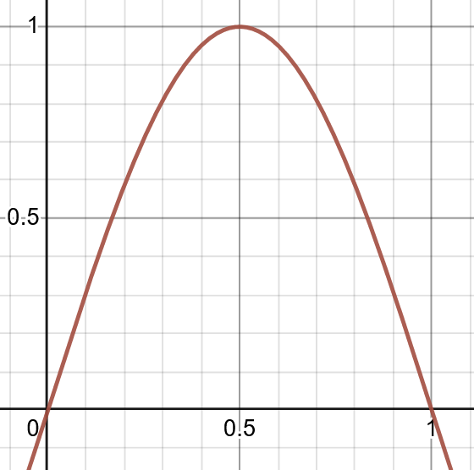
Draw the tangent line to f at x = 0.5 and use it to approximate f’(0).
$f'(0.5)≈______$
If h = 0.5, for each of the following difference quotients, draw the line and approximate f’(0)
- Forward difference quotient or average slope on [0.5,0.5+h]
$f'(0.5)≈______$
- Backward difference quotient or average slope on [0.5-h,0.5]
$f'(0.5)≈______$
- Centered difference quotient or average slope on [0.5-h,0.5+h]
$f'(0.5)≈______$
Which approximation is closest to the actual value of f’(0)

- Given that $y=fIx)=x^{3}$,
  - Calculate f’(x) using the algebraic definition with the backward difference quotient, the forward difference quotient and the centered difference quotient.

  - Verify that they all give the same answer

  - Why would these calculations suggest that the central difference quotient works best?

