Limits Activity – Part 2

Name______________________

1. Given the flowing graph of the function *f,* find the following:


 $\lim_{x→2^{-}}{f\left(x\right)}$

 $\lim_{x→2^{+}}{f\left(x\right)}$

 $\lim_{x→2}{f\left(x\right)}$

3. *f(2)*

$\lim_{x→8^{+}}{f\left(x\right)}$

$f(8)$

$\lim_{x→8^{-}}{f\left(x\right)}$

g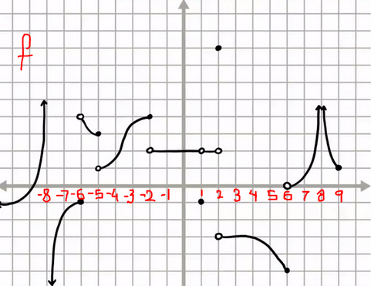

1. Draw a graph of a function *f* in the axes below that satisfies the following criteria:

* $f\left(-3\right)=1$ and $\lim_{x→-3}{f\left(x\right)}=1$
* $f\left(-1\right)=2$ and $\lim_{x→-1}{f\left(x\right)}=4$
* $f\left(0\right)=-2$, $\lim_{x→0^{+}}{f\left(x\right)}=-2$ and $\lim_{x→0^{-}}{f\left(x\right)}=2$
* $f\left(1\right)=Undefined$ and $\lim_{x→1}{f\left(x\right)}=2$
* $f\left(3\right)=0$ and $\lim_{x→3}{f\left(x\right)}=Undefined$

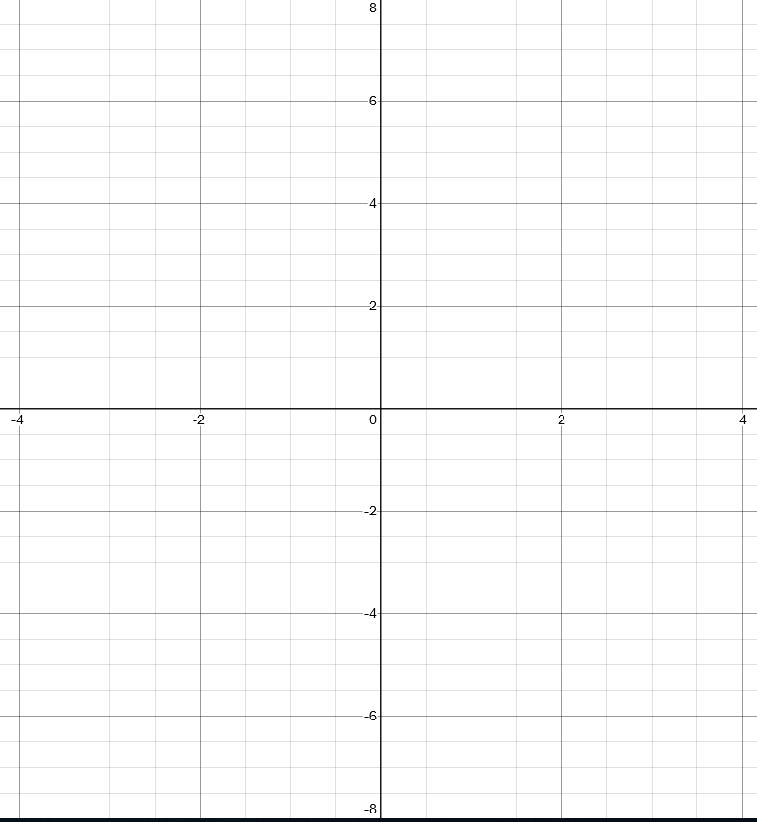

1. Given that
   * 1. Find the *x* and *y* intercepts of *f.*
     2. Find the long term behavior of *f* as $x→±∞$.
     3. Find the limits from the left and the right for all values of *x* for which *f(x)* is undefined.
     4. Draw a graph of *f* that is consistent with the above.
2. If *x = hours since 12:00* and $f\left(x\right)=x^{2}$ is the mile marker of a car at the time *x.*
   1. Write an expression for the average velocity (slope) on the interval [1,1+h].
   2. Use the formula in a to fill in the following table:

|  |  |
| --- | --- |
| *h* | Average velocity on the interval [1,1+h]. |
| 1 |  |
| .1 |  |
| .01 |  |
| .001 |  |

* 1. Use the table from part b tp guess the value of the limit as h→0 of the average velocity (slope) on the interval [1, 1+h].
  2. Take the limit algebraically as h->0 of the average slope on the interval [1, 1+h] to find the instantaneous slope at x = 1.

1. If *x = seconds* and $f\left(x\right)={100-5x}^{2}$ returns the height of an object in meters after x seconds*.*
2. Write an expression for the average velocity on the interval [2,2+h].
3. Use the formula in a to fill in the following table:

|  |  |
| --- | --- |
| *h* | Average velocity on the interval [2,2+h]. |
| 1 |  |
| .1 |  |
| .01 |  |
| .001 |  |

* 1. Use the table from part b tp guess the value of the limit as h→0 of the average velocity (slope) on the interval [2, 2+h].

1. Take the limit algebraically as h->0 of the average slope on [2, 2+h] to find the instantaneous slope at x = 2.
2. For each of the functions and points in parts a,b and c below, perform steps (i) and (ii) to find the instantaneous rate of change (slope) at the indicated point:
   * 1. Write an expression for the average rate of change of *f* on the interval *[a,a+h]* where *a* is the indicated point.
     2. Take the algebraic limit as h->0 of the average slope on [a, a+h] to find the instantaneous slope at the indicated point.

$f\left(x\right)=x^{3}, a=2$

$f\left(x\right)={2x}^{2}, a=3$

$f\left(x\right)={3x}^{2}+2x+1, a=1$