Limits Activity

Name______________________

Name of Group Members_________________

1. Given the flowing graph of the function *f* find the following




 $\lim_{x→{-5}^{-}}{f\left(x\right)}$

 $\lim_{x→-5+}{f\left(x\right)}$

 $\lim_{x→-5}{f\left(x\right)}$

$\lim_{x→1^{+}}{f\left(x\right)}$

$\lim_{x→1}{f\left(x\right)}$

5. *f(1)*

$\lim_{x→{-8}^{+}}{f\left(x\right)}$

g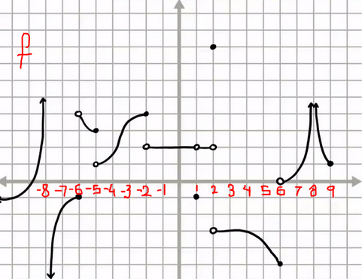

1. Find the following limits:
$\lim_{x→-7}\frac{x-7}{x^{2}-9}$

$\lim_{x→2+}{\frac{1}{x-2}}$

$\lim_{x→2-}{\frac{1}{x-2}}$

$\lim_{x→7}\frac{x-7}{x^{2}-49}$

$\lim_{x→-1}{\frac{x^{2}-x-2}{x+1}}$

2. Draw a graph of a function *f* in the axes below that satisfies the following criteria and then indicate at what points the graph is discontinuous:

* $f\left(-2\right)=2$ and $\lim_{x→-2}{f\left(x\right)}=1$
* $f\left(-1\right)=3$ and $\lim_{x→-1}{f\left(x\right)}=3$
* $f\left(0\right)=-1$, $\lim_{x→0+}{f\left(x\right)}=-2$ and $\lim_{x→0-}{f\left(x\right)}=2$
* $f\left(1\right)=Undefined$ and $\lim_{x→1}{f\left(x\right)}=0$
* $f\left(2\right)=1$ and $\lim_{x→2}{f\left(x\right)}=Undefined$

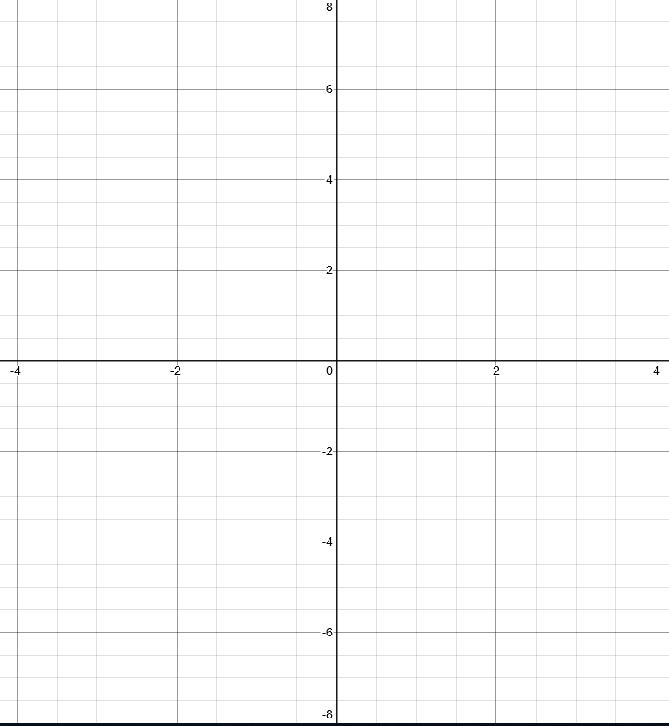

1. Given that $f\left(x\right)=\frac{(x+3)(x-1)}{(x-1)(x+1)}$
2. Find the following linits:
$\lim_{x→1^{+}}{f\left(x\right)}$

$\lim_{x→1^{-}}{f\left(x\right)}$

$\lim_{x→-1^{+}}{f\left(x\right)}$

$\lim_{x→{-1}^{-}}{f\left(x\right)}$

3. What are the *x* and *y* intercepts of *f?*
4. What is the long term behavior of *f* as $x→±∞$?
5. Draw a graph of the function *f* consistent with all the above.

1. For each of the following,
   * 1. Constuct a numberline with the signs of *f (+,-,0,undefined)*
     2. Find the *x* and *y* intercepts of *f*
     3. Find the limits from the left and the right for all values of *x* for which *f(x)* is undefined.
     4. Find the long term behavior of *f* as $x→±∞$
     5. Draw a graph of *f* that iss consistent with the above.

$f\left(x\right)=\frac{\left(x-1\right)}{x^{2}+3x-4}$

$f\left(x\right)=\frac{(x-1)}{x^{2}-3x-10}$

$f\left(x\right)=\frac{1}{x^{2}-2x-8}$

$f\left(x\right)=\frac{1}{x^{3}-4x^{2}+4x}$