Constant Rates of Change Worksheet

Name __________________

1. Fill in the blanks for the following
$3 \frac{miles}{ hr}=\frac{12 miles}{ ___ hr}=\frac{___}{2 hr}=\frac{1 mile}{}=\frac{}{0.1 hr}=\frac{}{0.01 hr}$

$20 \frac{miles}{ hr}=\frac{80 miles}{ ___ hr}=\frac{___}{5 hr}=\frac{1 mile}{}=\frac{}{0.1 hr}=\frac{}{0.01 hr}$

$10 \frac{dollars}{ hr}=\frac{\$90}{ ___ hr}=\frac{___}{4 hr}=\frac{\$1 }{}=\frac{}{0.1 hr}=\frac{}{0.01 hr}$

2. Place numbers next to each to order the following salaries from smallest to largest salary:
   1. 7 dollars per 3 hours
   2. 3 dollars per half hour
   3. 2 dollars per 0.25 hour
   4. 32 dollars per 8-hour day
   5. 320 dollars per 40-hour week
   6. 9 dollars per 0.75 hours
3. For each row, express the salary with the indicated salary units.

|  |  |  |  |  |
| --- | --- | --- | --- | --- |
| Salary | Dollars per hour | Dollars per ½ hour | Dollars per 3 hours | Dollars per 8-hour day |
| $6 per 5 hours |  |  |  |  |
| $2 dollars per half hour |  |  |  |  |
| $3 dollars per 0.25 hour |  |  |  |  |
| $72 dollars per 8-hour day |  |  |  |  |
| $320 dollars per 40-our week |  |  |  |  |
| $6 per 0.6 hours |  |  |  |  |

1. Which units for salaries are most practical in Problems 2 and 3? Why?
2. Given that

*x = number of minutes displayed on an ongoing timer*

*y = f(x) = gallons of liquid in a tank*

If we assume a constant flow of liquid for each row, fill in the following table:

|  |  |  |  |  |
| --- | --- | --- | --- | --- |
| *(x1,y1)* | *(x2,y2)* | Gallons per minute | Gallons per 1/60 of a minute (gal/sec) | Gallons per 60 minutes (gal/hour) |
| (2,9) | (5,15) |  |  |  |
| (3,45) | (13,125) |  |  |  |
| (2,34) | (7,64) |  |  |  |
| (2,30) | (4,36) |  |  |  |

1. Given that

*x = hours that have gone by since 12:00*

*y = f(x) = mile marker on the highway that represents our location*

If the first column contains the formula for *f*, fill in the following table with two points (x1,y1) and (x2,y2) that will let us find each of the associated velocities in the given column:

|  |  |  |  |  |
| --- | --- | --- | --- | --- |
| Formula | Two points for miles per hour | 2 pts for miles per ½ hour | 2 pts for miles per 5 hours | 2 pts for miles per 24-hour day |
| *y = 10x* |  |  |  |  |
| *y = 25x* |  |  |  |  |
| *y = 15x + 12* |  |  |  |  |
| *y = 30x + 36* |  |  |  |  |
| *y = 20x +`300* |  |  |  |  |
| *y = 3x + 4* |  |  |  |  |

use the results of the above table to express the velocity of each row in the units indicated for the given columns:

|  |  |  |  |  |
| --- | --- | --- | --- | --- |
| Formula | Velocity in miles per hour | Velocity in miles per ½ hour | Velocity in miles per 5 hours | Velocity in miles per 24-hour day |
| *y = 10x* |  |  |  |  |
| *y = 25x* |  |  |  |  |
| *y = 15x + 12* |  |  |  |  |
| *y = 30x + 36* |  |  |  |  |
| *y = 20x +`300* |  |  |  |  |
| *y = 3x + 4* |  |  |  |  |

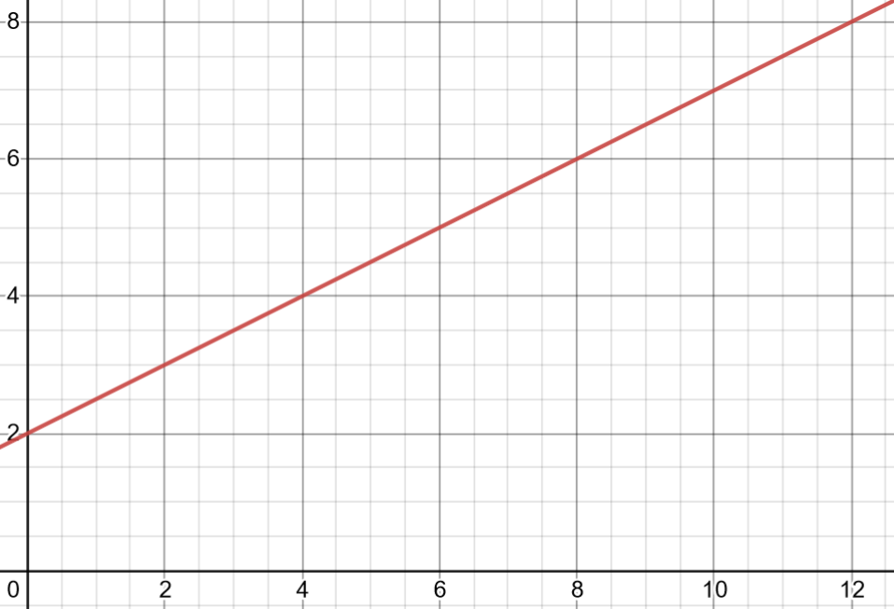

1. Given that

*x = hours that have passed since 12:00 noon*

*y = f(x) = mile marker on the highway that represents our location*

If the above graph represents the function *f*, fill in the following table with two points (x1,y1) and (x2,y2) that will let us find each of the associated velocities in the given column:

|  |  |  |  |
| --- | --- | --- | --- |
| Two points for miles per hour | 2 pts for miles per ½ hour | 2 pts for miles per 5 hours | 2 pts for miles per 8-hour work day |
|  |  |  |  |

Use the results of the previous table to express the velocity of each row in the units indicated for the given columns:

|  |  |  |  |
| --- | --- | --- | --- |
| Velocity in miles per hour | Velocity in miles per ½ hour | Velocity in miles per 5 hours | Velocity in miles per 8 hour work day |
|  |  |  |  |

1. Optional:
   1. Create a situation (with associated x and y variables) so that there is an associated slope equal to 4. Be sure to include the units of x and y when describing the situation.
   2. Create, a table of values, a formula and a graph that can represent this same situation.
   3. Find sets of two points associated with the situation where
 $x=1 and ∆x=3$

 $x=2 and ∆x=0.1$

 $x=3 and ∆x=0.01$

4. For part bi,ii and iii, does the slope change? Why or why not?