Math Fact Fluency Background:
- Purpose: derived fact strategy game for all multiplication and division
- Encourage players to use the Adding a Group and Subtracting a Group strategies
- The key is to make practice through games as meaningful and strategy focused as possible.
About Games and Math Fact Fluency:
Games are fun. But, more importantly, games are effective ways to support learning. Games provide opportunities for:
- low-stress practice of (1) facts and (2) strategies (both outcomes are critical to math beyond the basic facts!).
- think aloud, an effective learning strategy. Therefore, students should develop the habit of verbalizing their mathematical thinking out loud.
- student listening and learning from peers. Therefore, discussing strategies before and after playing allows students opportunities to learn from each other.
- teachers to formatively assess and plan instruction. Therefore, at times, use an observation tool to record how students are progressing.
Effective math fact fluency games remove time pressure and allow students time to think. That means no time component. Each player has their own cards or dice to roll, so they are not racing each other. Scoring is de-emphasized. Thinking strategies are front and center.
Strive to Derive 2 to 4 players
Materials: array cards (showing arrays for the 3s, 6s, 9s, and 10s that are labeled with the corresponding facts), one marker per student (uncooked spaghetti, coffee stirrer, thin straw or skewer, etc.)
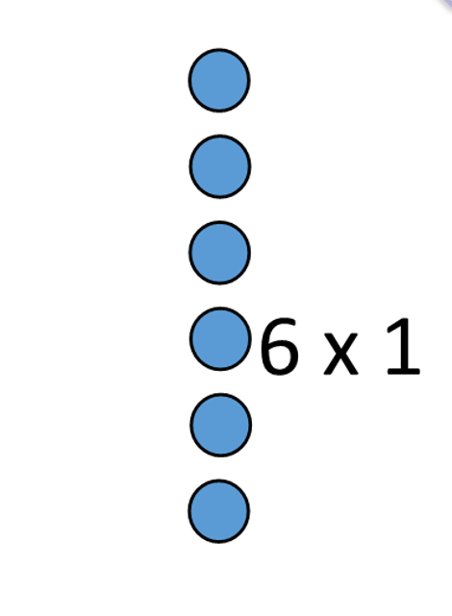

Strive to Derive 2 to 4 players
How to Play:
- Players spread out the array cards so they can be seen.
- Player 1 selects an array for the person to their right.
- Player to the right must find a way to use the marker to partition the array into two or use one of the 10s array cards to show the Subtracting a Group Strategy.
- Player illustrates and explain how to use Adding a Group or Subtracting a Group to find the fact to earn a point.
- Return the array to the middle and the next player has a turn.
- Players earn a point if they can explain the strategy used to find the product.
- Repeat steps until a player earns 10 points.

Game in Action:
Players score points by illustrating and explaining how to use Adding a Group or Subtracting a Group to find the fact. Player that scores 10 points first wins the game.
For example: A player selects “3 x 7” array for the player to the right. The other player uses “3x10” array to show subtraction of 3 equal groups of 3.

I just got array card 3 x 7. I know that 3 x 10 = 30 and I know 3 x 3 = 9. I am going to use the strategy Subtract a Group 3 x 10 minus 3 x 3 equals 3 x 7. The answer is 21.

Possible Variations:
- Require that players divide the array so that one of the parts is a 5s fact.
- Roll two 10-sided dice to determine the dimensions of the array. Players either find that array in the cards or draw before partitioning it.

