Math Fact Fluency Background:
- Purpose: foundational fact strategy game for multiplication and division
- Practice selected strategies such as equal groups and arrays. Discuss them before and after playing.
- Encourage players to picture an image of facts to find products without skip counting and deemphasize speed.
About Games and Math Fact Fluency:
Games are fun. But, more importantly, games are effective ways to support learning. Games provide opportunities for:
- low-stress practice of (1) facts and (2) strategies (both outcomes are critical to math beyond the basic facts!).
- think aloud, an effective learning strategy. Therefore, students should develop the habit of verbalizing their mathematical thinking out loud.
- student listening and learning from peers. Therefore, discussing strategies before and after playing allows students opportunities to learn from each other.
- teachers to formatively assess and plan instruction. Therefore, at times, use an observation tool to record how students are progressing.
Effective math fact fluency games remove time pressure and allow students time to think. That means no time component. Each player has their own cards or dice to roll, so they are not racing each other. Scoring is de-emphasized. Thinking strategies are front and center.
Squares Bingo 2 or more players
Materials: blank 5 x 5 Bingo board, student recording sheet, Bingo chips or counters, deck of playing cards for the teacher with kings and jacks removed (ace = 1, queen = 0), pencils for each player or dry erase makers if laminated or using dry erase sleeves.
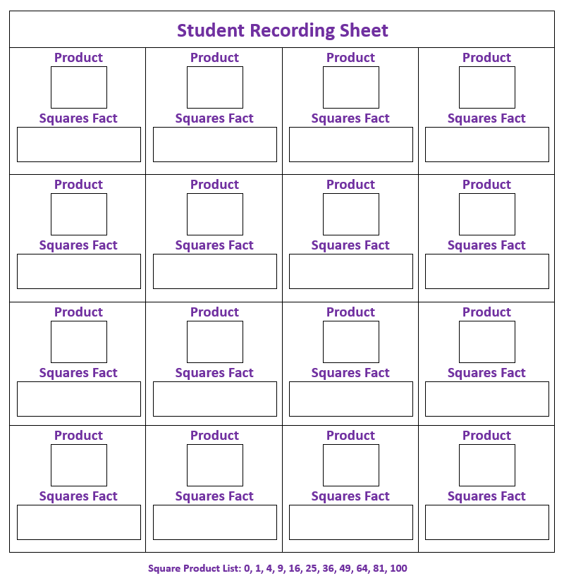
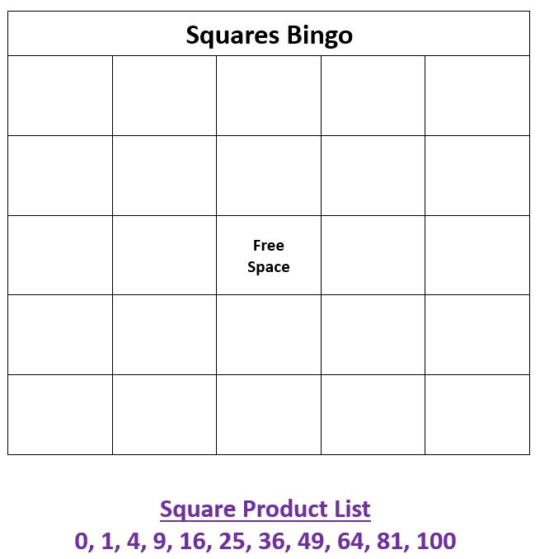
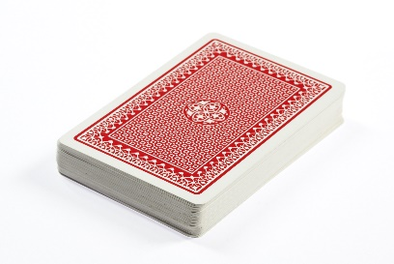

Squares Bingo 2 or more players
How to Play:
- Players copy square products: 0,1,4,9,16,25,36,49,64,81, and 100 onto their Bingo boards with pencils or dry erase markers. Some numbers will be repeated and not all numbers must be used.
- Player or teacher draws a card from the deck. Then, players calculate and record the square product of that number on their student recording sheet.
- Players cover the square product of that number on their Bingo board with counters or chips. Only one space can be covered each turn and chips cannot be removed once they have been placed.
- Continue to take turns drawing cards and covering numbers until a player wins.
Game in Action: The game ends when a player gets five in row horizontally, diagonally, or vertically. Players record products onto player score card.
For example: A player draws a queen, records the product onto their student recording sheet (0 X 0 = 0), and covers the value on the BINGO card.

Squares Bingo
4 | 100 | 16 | 49 | 9
64 | 9 | 36 | 4 | 81
25 | 81 | Free  Space | 64 | 1
36 | 25 | 0 | 9 | 81
100 | 25 | 81 | 100 | 25
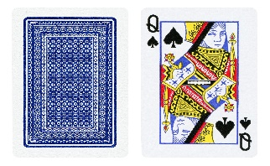

Possible Variations:
- Use other fact groups on the game board.
- Use a 4 x 4 Bingo board.

