Math Fact Fluency Background:
- Purpose: derived fact strategy game for multiplication and division
- Targets 5’s facts
- Encourage students to use strategies rather than skip count.
- The key is to make practice through games as meaningful and strategy focused as possible.
About Games and Math Fact Fluency:
Games are fun. But, more importantly, games are effective ways to support learning. Games provide opportunities for:
- low-stress practice of (1) facts and (2) strategies (both outcomes are critical to math beyond the basic facts!).
- think aloud, an effective learning strategy. Therefore, students should develop the habit of verbalizing their mathematical thinking out loud.
- student listening and learning from peers. Therefore, discussing strategies before and after playing allows students opportunities to learn from each other.
- teachers to formatively assess and plan instruction. Therefore, at times, use an observation tool to record how students are progressing.
Effective math fact fluency games remove time pressure and allow students time to think. That means no time component. Each player has their own cards or dice to roll, so they are not racing each other. Scoring is de-emphasized. Thinking strategies are front and center.
Trios 2 players
Materials: One deck of playing cards with jacks and kings removed (ace=1, queen=0) OR one 10-sided die, one 5x5 game board with a multiple of 5 in each square, 15 counters in one color and 15 in another color (or two colors of markers).
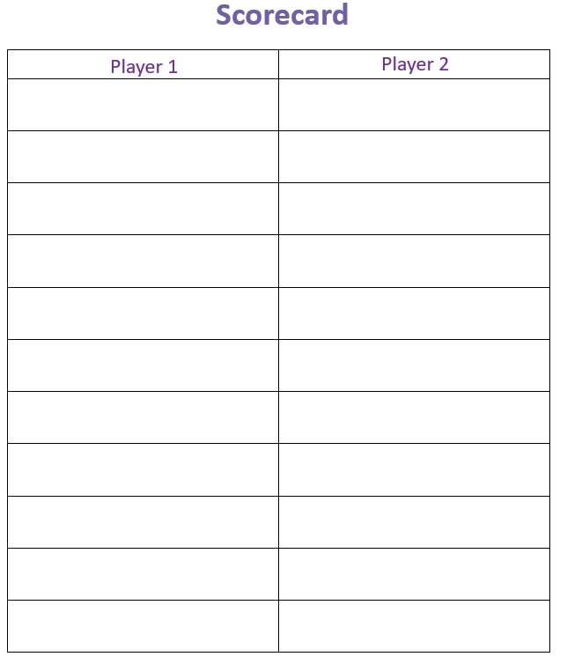
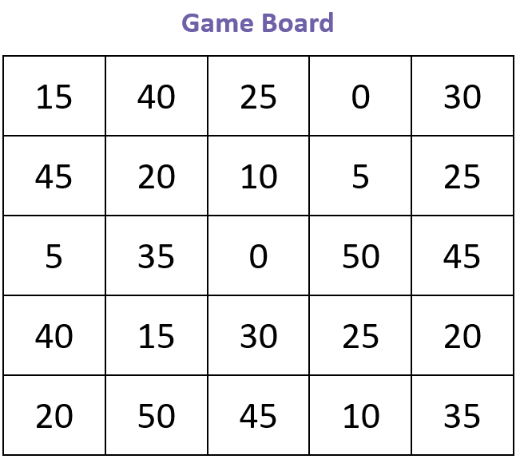

Trios 2 players
How to Play:
- Player 1 rolls one die (or picks a card)
- Multiply the number by 5.
- Place a counter of the chosen number on any square with that product. Only cover one number for each turn.
- Repeat all steps for Player 2.
Game in Action: Score 5 points for covering a trio. Players cover three spaces in a row (horizontally, vertically, or diagonally) with the same color to make Trios. Players take turns picking a card or rolling the die and covering numbers until the board is full or time is up. The person with the highest score wins.
For example: Players records trios in table and earns 5 points for every trio on the board. Player 2 has earned 15 points.
Scorecard
Player 1 | Player 2
5, 10, 60 | 35,20,10
40,15,30 | 15,25,45
 | 50, 15, 20

20 | 5 | 20 | 30 | 40 | 5
35 | 55 | 10 | 45 | 15 | 20
50 | 15 | 20 | 60 | 30 | 35
20 | 25 | 50 | 25 | 55 | 15
32 | 45 | 40 | 35 | 20 | 10

Possible Variations:
- Change the size of the game board. Mark more spaces.
- Change the multiples on the board for other fact sets.
- Require four or more in a row to win.
- Pair students into teams and play two teams per game board. This promotes mathematical discussion between partners.

