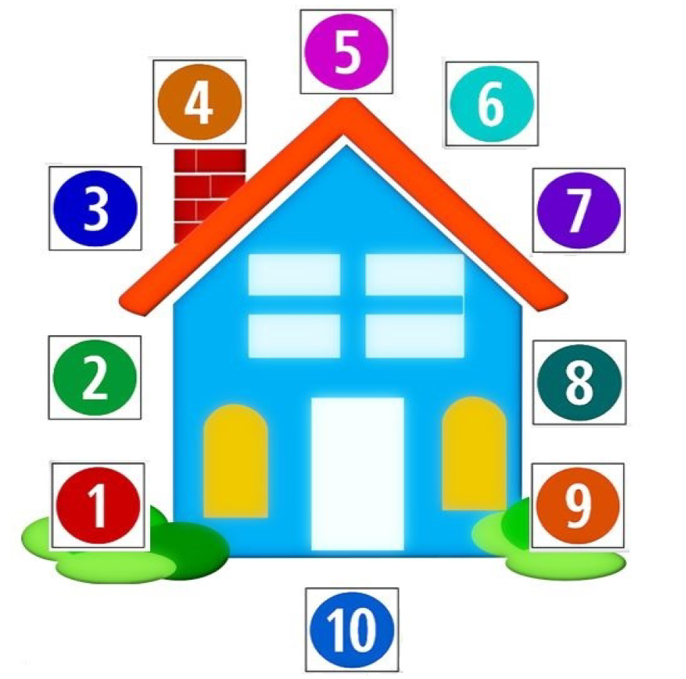
Score Card
Equation Equals | Equation
1
2
3
4
5
6
7
8
9
10
12
101
11
9
20
2
1
19
3
14
13
15
8
7
16
17
6
5
4
18
Score Card
Equation Equals | Equation
1
2
3
4
5
6
7
8
9
10
Score Card
Equation Equals | Equation
11
12
13
14
15
16
17
18
19
20

