Using Sum War for Math Fact Fluency:
- Derived Fact Strategy Game for Addition
- Targeted Facts: Sums within 20
- Derived fact strategies for addition and subtraction require a focus on strategy selection and flexibility.
- Foundational facts must precede derived facts. Students use the foundational facts they have mastered to develop derived fact strategies for addition and subtraction.
- Assess students for automaticity with foundational facts to determine readiness for derived fact strategies.
- Near Doubles, Making 10, and Pretend a Ten are accessible, commonly used, and powerful strategies students may use during Sum War.
About Games and Math Fact Fluency:
Games are fun. But, more importantly, games are effective ways to support learning. Games provide opportunities for:
- low-stress practice of (1) facts and (2) strategies (both outcomes are critical to math beyond the basic facts!).
- think aloud, an effective learning strategy. Therefore, students should develop the habit of verbalizing their mathematical thinking out loud.
- student listening and learning from peers. Therefore, discussing strategies before and after playing allows students opportunities to learn from each other.
- teachers to formatively assess and plan instruction. Therefore, at times, use an observation tool to record how students are progressing.
Effective math fact fluency games remove time pressure and allow students time to think. That means no time component. Each player has their own cards or dice to roll, so they are not racing each other. Scoring is de-emphasized. Thinking strategies are front and center.
Sum War 2 players
Materials: deck of cards with Kings and Jacks removed (aces = 1, queens = 0), student recording sheet
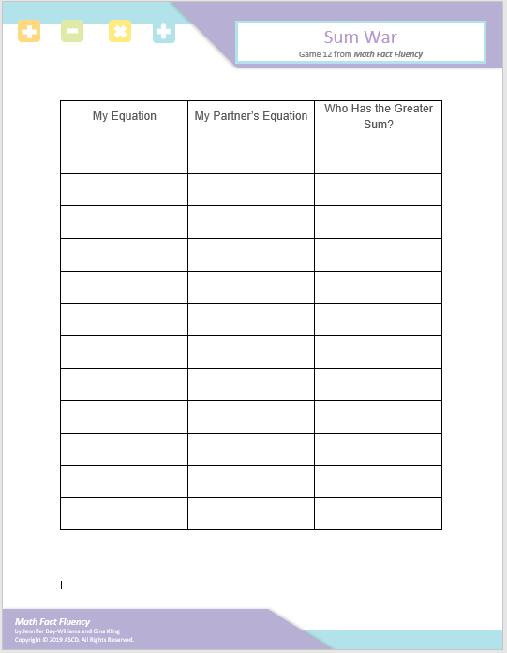

Sum War 2 players
How to Play:
- Divide the deck evenly between the two players.
- At the same time, both players flip over their top two cards and call out the sum of their numbers.
- Each player takes turns saying their answer and sharing their thinking strategy. Both players decide if the sums are correct.
- Both players correct: The player with the larger sum wins the hand and gets the cards.
One player is correct: That player wins the hand and gets the cards.
Neither player is correct: Cards go to the bottom of each player’s deck.
- If there is a tie, it is a “war” and partners repeat steps 2-4
- Play continues until one of the decks is gone or time is called.
Game in Action:
I am going to pretend the 9 is a 10. I know 10 + 4 equals 14. I have to take one away from my answer. One less than 14 is 13!
The 8 is 2 away from 10. I moved 2 over to make a 10. 10 + 3 equals 13!

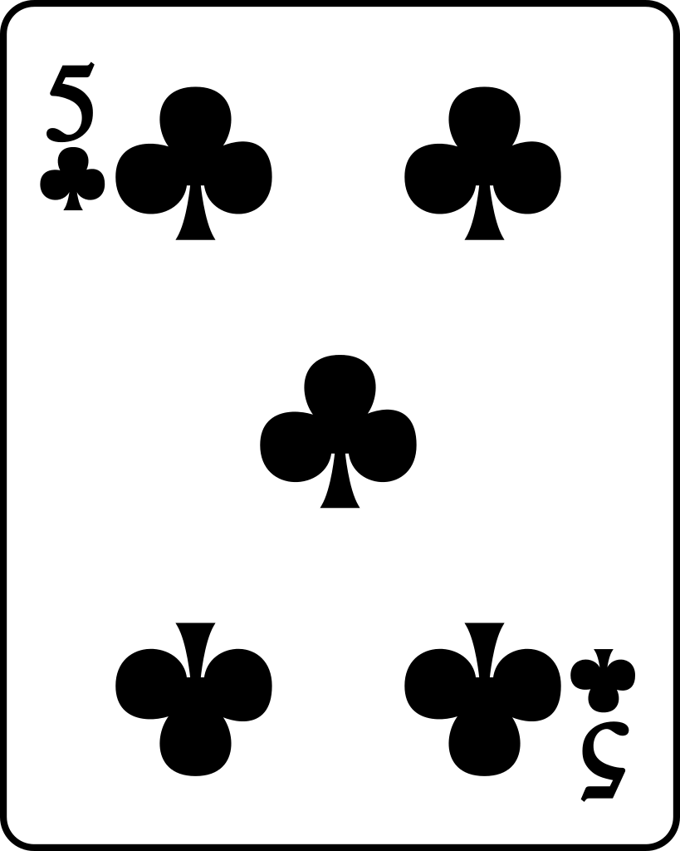
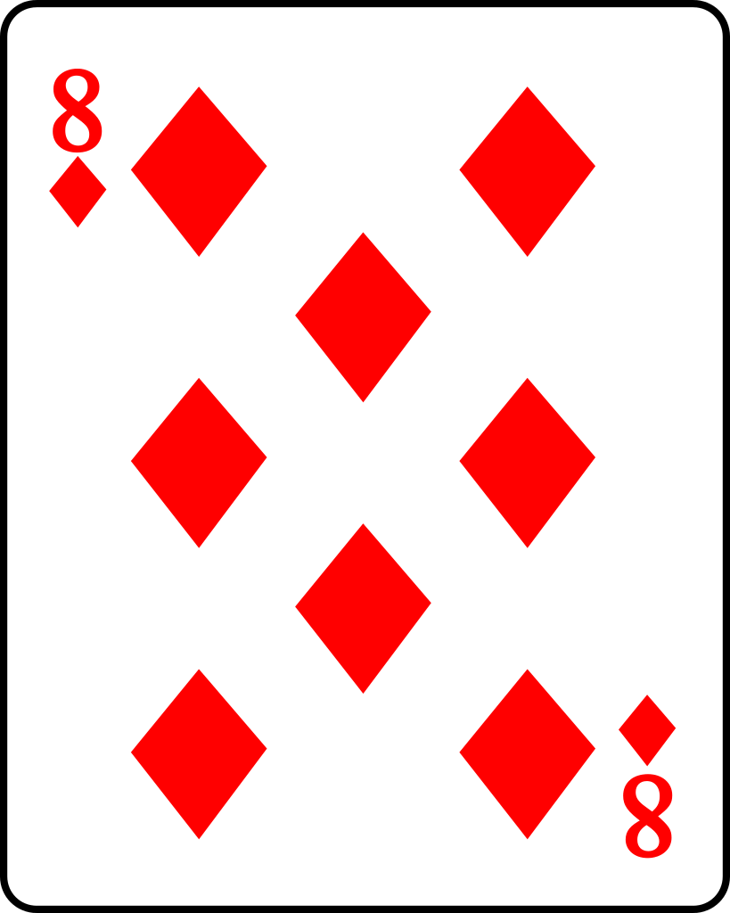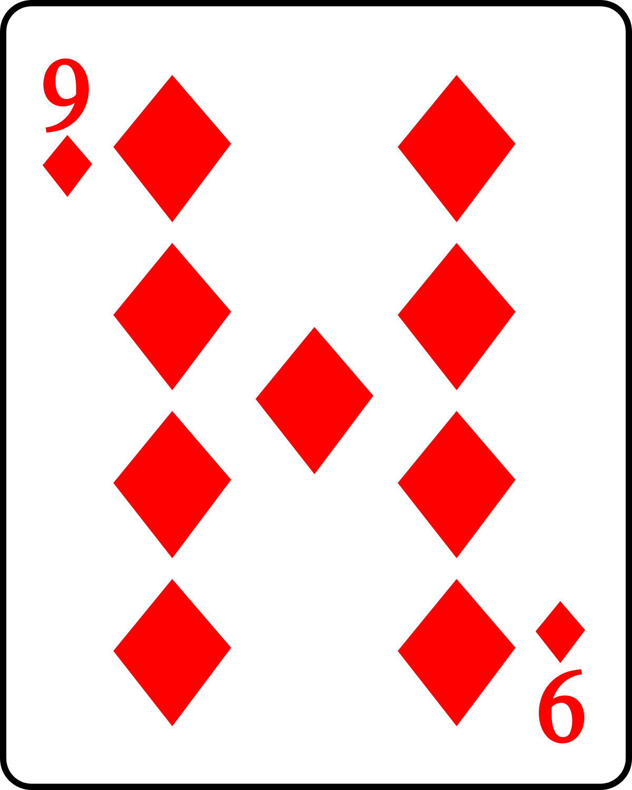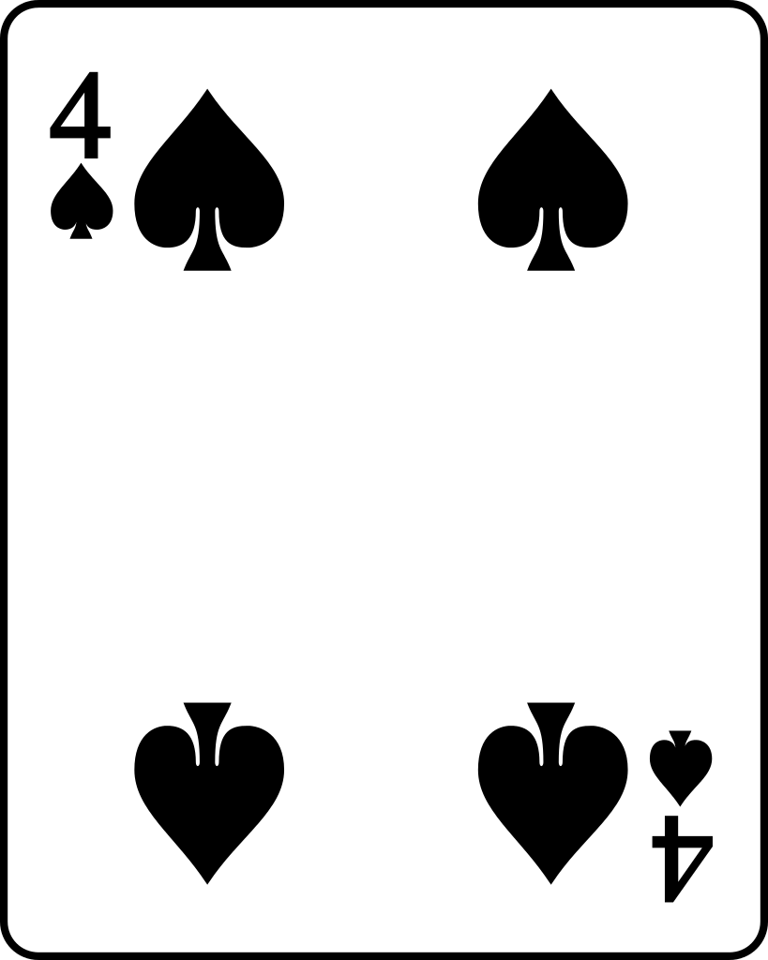
This Photo by Unknown Author is licensed under CC BY-SA
This Photo by Unknown Author is licensed under CC BY-SA
This Photo by Unknown Author is licensed under CC BY-ND
This Photo by Unknown Author is licensed under CC BY-SA
This Photo by Unknown Author is licensed under CC BY-SA
Possible Variations:
- Only use cards 0 – 5.
- Use 3 addends (three cards each).
- Change to subtraction. Find the difference, and the player with the lesser difference wins the cards.
- Change to multiplication, comparing products instead of sums.
- Change who wins the game. The person with the lowest score could win the game and circle their equation on the blank score card.
- A blank score card is included for variations.

