MATH FACT FLUENCY
Teachers + Students + Families
Success with

The Doubling Strategy

What does doubling look like? When is doubling useful?
Doubling: $×$ 4

It works great for the 4s facts, and is sometimes called Double and Double Again. Have a look!

Marvin arranged his new set of Legos into four rows. Each row has seven pieces.

I know…
2 groups of 7 is 14:
2 x 7 = 14
Doubling 14 is 28: 14 + 14 = 28

Thinking about 14 + 14 is more efficient than skip counting, 7 + 7 + 7 + 7.
Extending Doubling: $×$ 6 and $×$ 8
Doubling works for other even numbers, like 6 facts and 8 facts. Once your child knows their 3s facts, they double to solve for 6s; once they know their 4s facts, they double to solve 8s. Have a look at a fact that is commonly difficult for children: 7 $×$6 or 6 $×$7.

6 $×$7 means 6 groups of 7. I know 3 $×$ 7 = 21. I double 21 to get 42.
6 $×$7 = 42.

Extending Doubling: Beyond Basic Facts
(see “fact #5” above)

Doubling and halving turns problems into ones that can be solved mentally – very useful!
Examples:
12 $×$ 15  Double  Half  Double  6 $×$ 30  180 | 5 $×$ 380 300 + 80  Half  10 $×$ 190 150 + 40  1,900 | 4.5 $×$ 8  Half  Double  9 $×$ 4  36

Multiplication Strategy Rationale

Research-based learning facts:
- Students start learning multiplication facts by skip counting. That is natural, but they must progress to more efficient reasoning strategies.
- Implementing reasoning strategies may initially be slower than counting, but eventually it is faster and will lead to quick recall (automaticity), with the added (critical) benefit of long-term retention (rather than forgetting a fact and having to drop back to skip counting).
- Visuals and stories help students to understand the reasoning strategy.
- Mathematical reasoning emerges as children notice patterns and relationships through repeated opportunities. Playing purposeful math games is a great way to do this (see pages 3 and 4)!
- Reasoning strategies themselves are important to learn because they generalize to larger numbers. Learning the strategies builds stronger math skills!

Thank you for your support in developing fact fluency with your child!

Games for Doubling and Learning Facts

Game: Switch (2 players)

Materials:
- One piece of paper, shared by all players
- 5 or 6 unique game pieces per player (e.g., colored counters or heads/tails of coins)
- Deck of cards, with Kings and Jacks removed; Queens = 0; Aces = 1

How to play:
- Write the multiples of 4 (0, 4, 8, 12, 16, 20, 24, 28, 32, 36, and 40) on a piece of paper (mix up the order of products to discourage skip counting as you play - see below).

- Shuffle the deck of cards and place them face down in a draw pile.

- Players take turns drawing one card and multiplying the drawn card by 4. The player places his/her game piece above the resulting product. For example, if a player draws the number 7, the player multiplies 7 by 4 and places a game piece above 28. Players share their strategy aloud (e.g., “I doubled 7 to get 14, and doubled again to get 28.”).

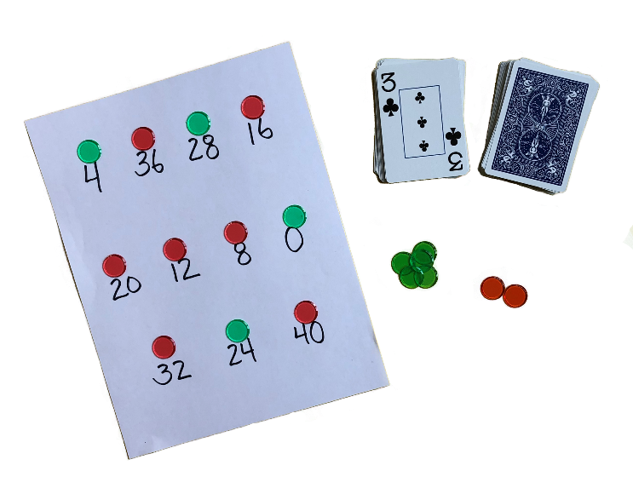
- If a player’s resulting product already has an opponent’s game piece on it, that player gets to SWITCH, placing their own game piece above that number, and returning their opponent’s game piece. If the player’s resulting product is one that they themselves already have, they lose that turn.

- To win:
Option 1: First to get 5 game pieces on the board
Option 2: Have the most game pieces when the board is completely covered (as illustrated here).
Pick an option and play best 3 out of 5!
Red Wins!

More ways to play:
Play with any fact set by creating a game board with the multiples of that set (e.g., $× 7)$. Play with three people (use three different colors of counters or three different coins).

Game: Fixed Factor War (Game 32, p. 88, Math Fact Fluency) (2 players)

Materials:
- Deck of cards, with Kings and Jacks removed. Queens = 0; Aces = 1.

How to Play:
- Find a 4 in the deck and place it between the two players (or 6 or 8) face up. That number is the fixed factor.

- Deal the rest of the cards equally, face down.

- Each player takes a turn to flip over the top card of his/her pile of cards. The player must state the product of the “fixed” factor card and the card they flipped, and share how they know (see example below).

- The player who correctly states the greater product in the round gets both players’ cards. (The “middle” fixed factor card stays.)

- If there is a tie, a “war” is declared, and players repeat the process, with the winner taking all played cards.

- The player with the most cards wins when time is up.

More ways to play: Use different Fixed Factors (e.g., a 6). Play Factor War – No fixed factor, each player draws 2 cards. Play with addition, too! (Fixed Addend War or Addend War)

Fixed Factor Card
(Does not change.)

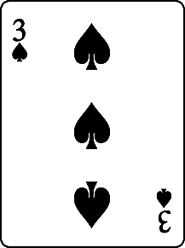
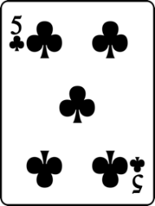
Player 1
Nicolas turns over a 3. He says, “Twelve. I doubled 3 to get 6 and doubled again to get 12.”
Player 2
MacKenna turns over a 5. She says, “Twenty. I just know my 5s, 5 times 4 equals 20.”

