MATH FACT FLUENCY
Teachers + Students + Families
Success with
Making 10 Strategy

What does Making 10 look like?

Story: Eight red tulips and six blue tulips bloomed in the garden.
How many tulips in the garden?
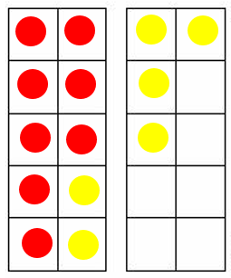
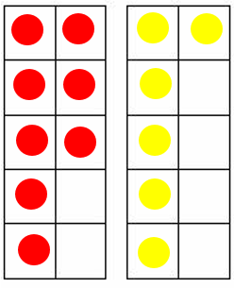
8 + 6
10 + 4
Visual:
8 + 6

2 4
10 + 4 = 14

Home Made Ten Frame for Hands-On Learning

Cut off two cups of an egg carton so that you have ten cups. Use any [safe] household objects as counters (e.g., erasers, Lego, coins, game pieces, candies, etc.).

When is Making 10 useful?

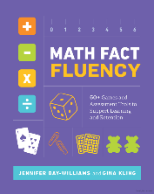
This is a great question to ask your child! For basic facts, it is useful anytime you are adding two numbers that have a sum greater than 10.
“
“
We know that strategy development is absolutely necessary for fluency. And fluency is essential to developing automaticity with basic facts (p.4).

Extending Making 10: Beyond Basic Facts
Making 10 might be the most useful reasoning strategy beyond the basic facts. Using Making 10 can eliminate the need to regroup or use other error-prone and more time-consuming steps. Compare the before and after of these four examples to see how the strategy creates an easier-to-solve problem.

1
“Move 1 over.”
Making 10s | Making 100s  “Move 4 over.” | Making 1s  Fractions  “Move over.”  $$\frac{1}{4}$$ | Making 1s  Decimals  “Move 0.1 over.”
29 + 15  $30$ + 14 | 4  278 + 496  274 + $500$ | $$\frac{1}{4}$$  $$3\frac{3}{4}+5\frac{3}{4}$$  $4 + 5\frac{2}{4}$ | 0.1  21.56 + 42.9  21.46 + 43
Addition Strategy Brief
- Students start learning addition by counting all, then learn more efficient strategies such as counting on. For facts with + 1 or + 2, counting on continues to be efficient; however, for facts like 8 + 6, counting is not efficient.

- Students who discover and learn reasoning strategies remember, retain, and outperform their peers who simply memorize their facts. Additionally, students who apply strategies develop confidence, not anxiety!

- Instruction should begin with stories and visuals to help students make sense of a reasoning strategy.

- Learning and using reasoning strategies initially takes more time than counting, but with sufficient, meaningful practice, it is eventually more efficient.

- When we focus on “fast” (memorization), we are encouraging students to not reason and not think, but rather just recall. Watch them revert to counting. That’s why the games below have no speed component!

- Reasoning strategies themselves are important to learn because they generalize to larger numbers. Learning the strategies builds stronger math skills for life!

- Playing purposeful math games is a great way for students to practice their reasoning strategies and learn their facts (see pages 3 and 4)!
Games for Making 10 and Learning Facts
Game: Lucky 13 (Game 11 in Math Fact Fluency) (2-4 players)

Materials:
- Deck of cards, with Kings and Jacks removed; Queens = 0; Aces = 1

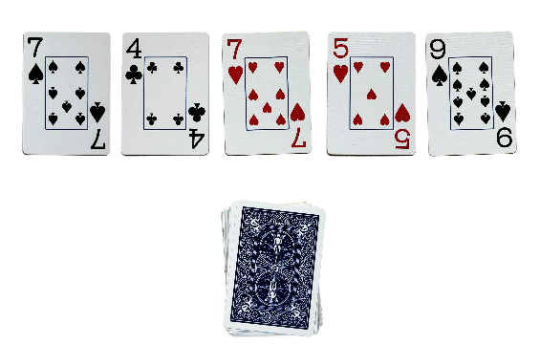
How to play:
Figure 1:
- One player is the dealer. The dealer gives each player 5 cards face up (see fig. 1).

- Each player selects 2 cards which, when added together, produce a sum as close to 13 as possible (see fig. 2).

- Players find how far their total is from ‘Lucky’ 13 and record that difference.

Examples:
Figure 2:
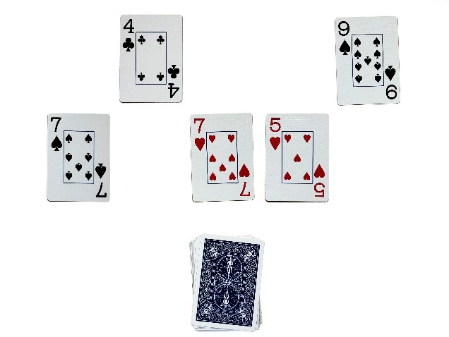
- Cards add to 9: Score is 4 (9 is 4 away from 13)
- Cards add to 15: Score is 2 (15 is 2 away from 13)
- Cards add to 13: Score is 0 (13 is 0 away from 13)
(see fig. 2)

- Players discard the two cards that were used and draw two new cards.

- Repeat for 5 rounds. Lowest score wins!

More ways to play: Deal only 4 cards; change the Lucky Number; use 3 addends (3 cards each); find a Lucky Difference (lucky number can be small, like 3).

Game: Sum War (Game 12 in Math Fact Fluency) (2 players)

Materials:
- Deck of cards, with Kings and Jacks removed. Queens = 0; Aces = 1.
How to Play:
- Split the deck in half so that each person has about the same number of cards.
- At the same time, partners turn up their top two cards and say the sum.
- Each player takes turns saying their answer, and sharing their thinking strategy. Both players decide if sums are correct:
- The player with the larger (correct) sum gets the cards.
- If there is a tie, it is a “war” and partners repeat steps 2 - 4.
- Optional: Play for a set time; player with the most cards wins.

More ways to play: Play Fixed Addend War (see variation of Game 32 in Math Fact Fluency). Identify a “fixed addend” card and place face up between two players (e.g., use 9 as your fixed addend if working on the strategy Making 10). Players divide the remaining cards equally, shuffle them, and place them face down. Each player draws one card and states the sum and how they found it. The larger sum wins the round.

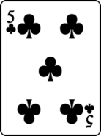
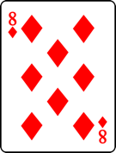
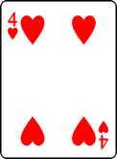
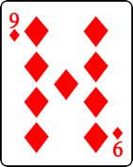
Player 1
This Photo by Unknown Author is licensed under CC BY-SA
Player 2

I moved one over to make 10. Ten and three equals thirteen.
The eight is two away from 10. I moved two over to make 10. Ten plus three equals thirteen.
War! Go again!

