Math Fact Fluency

Three KEYS to Helping Your Child Learn Basic Facts for Life AND Like Math

Why?
- Your child is much more likely to remember facts later on
- Your child is much less likely to have stress and anxiety
- The strategies will be used with greater numbers, fractions, and higher-level mathematics to support your child as a confident mathematician.
Focus on Real Math Fluency… use STRATEGIES
(rather than just memorize the facts with worksheets or flash cards)

#1
Learn

Help your child ‘see’ the reasoning STRATEGIES that generalize to numbers beyond basic facts.

Developing fluency involves children building understandings from within and taking an active part in constructing number sense. Essential to this development is children deriving strategies to approach problems and recognizing that they are capable of reasoning and finding relationships.

To get to that point, though, a child needs multiple opportunities to interact with number sense ideas, use number sense, and discuss number sense ideas and strategies.

#2
Life

Make practice enjoyable and meaningful.

- Play games.
- Talk through STRATEGIES.
- Focus on strategy selection, not speed. Speed will come with strategy practice.

#3
Like
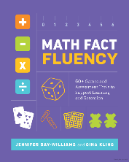

Addition Strategies

Making 10 | Example  9 + 6 | Pretend-a-10  [Compensation]
Imagine shifting some counters over to make a full 10, then add. | Talk | Pretend the biggest number is 10. Add. Adjust your answer to remove the extra you added.
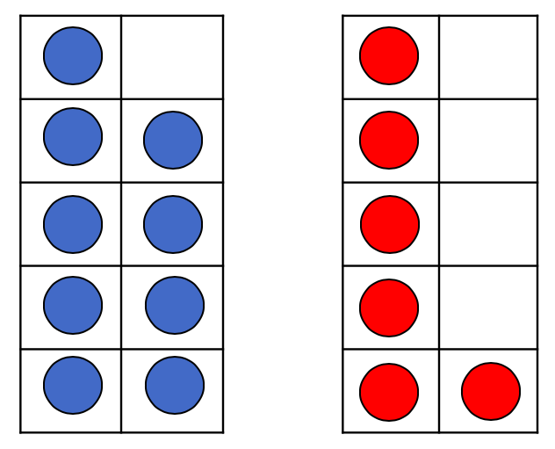
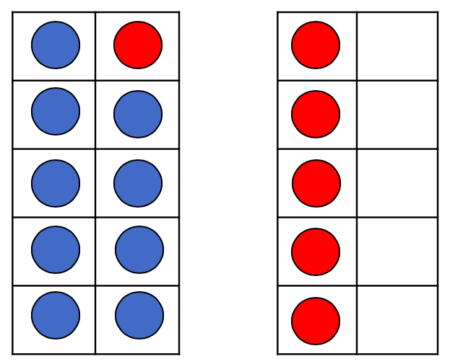
= | Ten Frames
 |  | 10 + 6 = 16
9 + 6 = 10 + 5 | Numbers | 9 + 6
= 15 |  | Subtract the extra one(s) you “pretended,” so  9 + 6 = 15
Home Made Ten Frame for Hands-On Learning

Cut off two cups of an egg carton so that you have ten cups. Use any [safe] household objects as counters (e.g., erasers, Lego, coins, game pieces, candies, etc.).

Why Strategies Matter:
Addition Strategies Extended to 3-digit Addition and Subtraction

A child with math fluency looks to see when these strategies can save them from doing
the more time-consuming standard algorithms.

“Making 10” | “Pretend-a-10” | “Pretend-a-10”
198 + 237 =  +2  –2 2  200 + 235 = 435 | 198 + 237 =  +2  200 + 237 = 437  –2  435 | 504 – 98 =  –2  504 – 100 = 404  +2  406
Multiplication Strategies
Doubling  (and Halving) |  | Break Apart  [Distributive Property]
With any even factor, I can use half that number to multiply and then double my answer. | Talk | I can take either factor and break it into two ‘friendly’ numbers, find the product of each part, and then join the parts together to find the product.
Think:
4 x 7  2 x 7 = 14 | Numbers  & | 6 x 8  Think: Which 8 facts do I know?  5 x 8 = 40  1 x 8 = 8  So, 6 x 8 = 48
2 x 7 = 14 | Models
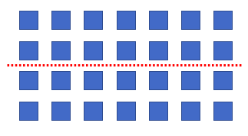  +  So, 4 x 7 = 28  If both factors are even – pick either one to halve, then double! | Tip: To help students see why these strategies work, use concept language like…  4 groups of 7,  4 sets of 7,  4 rows of 7  to help them understand the meaning of  4 times 7.
6 x 8 Think:

+
3 x 8 = 24
3 x 8 = 24

6 x 4 = 24
6 x 4 = 24

So, 6 x 8 = 48

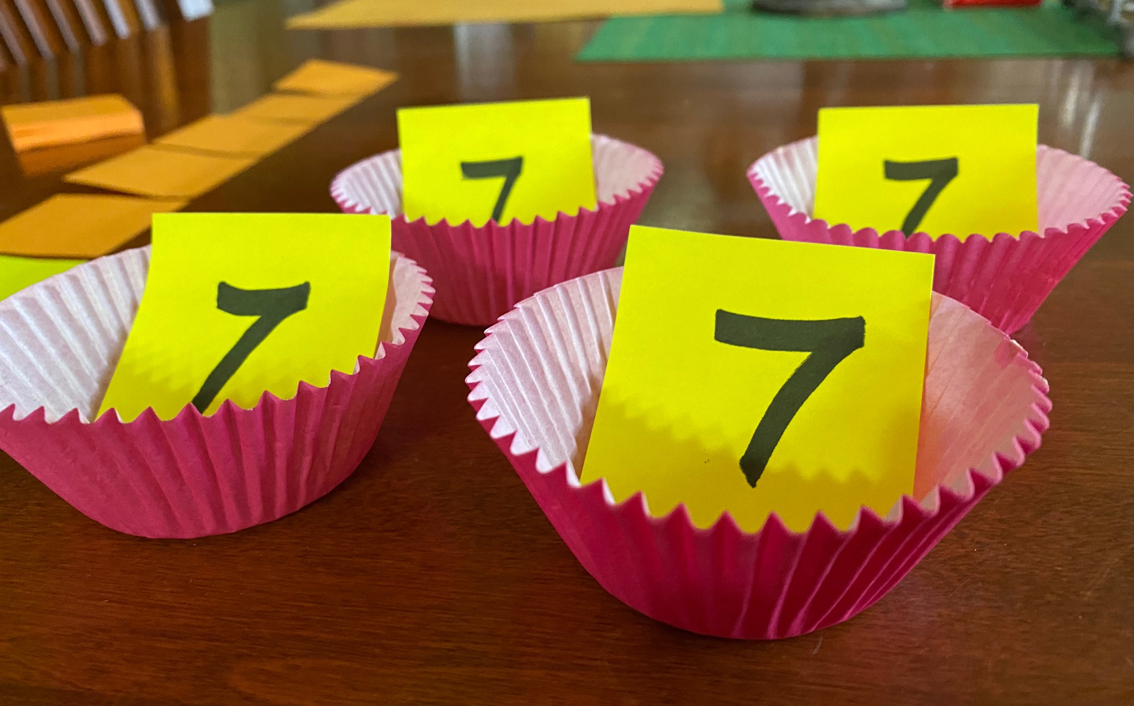
Home Made Materials for Hands-On Learning

Egg Carton Ten Frames (see above). Use small objects (jelly beans) as counters. For 4 × 7, fill 4 cups with 7 beans each.

Cupcake Cups (or Bowls). Start with counters, then eventually place numbers in each cup (using post-its). See how you can arrange the cups to show Doubling.

Games
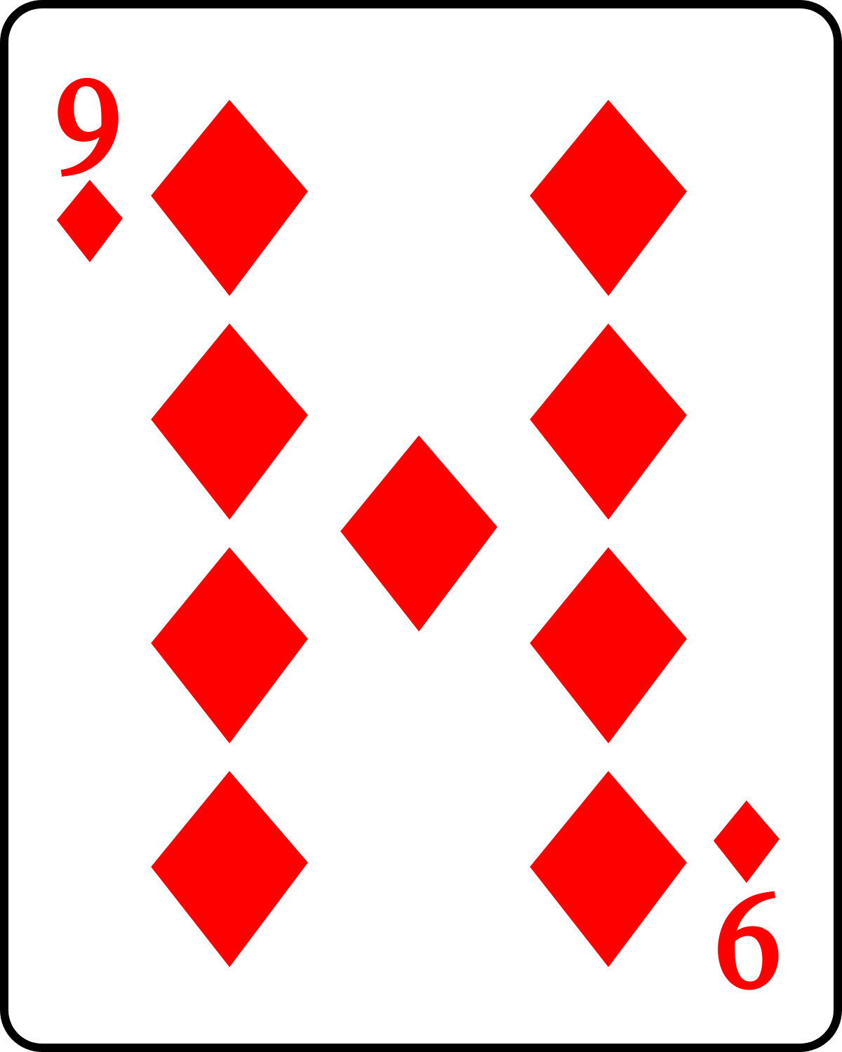
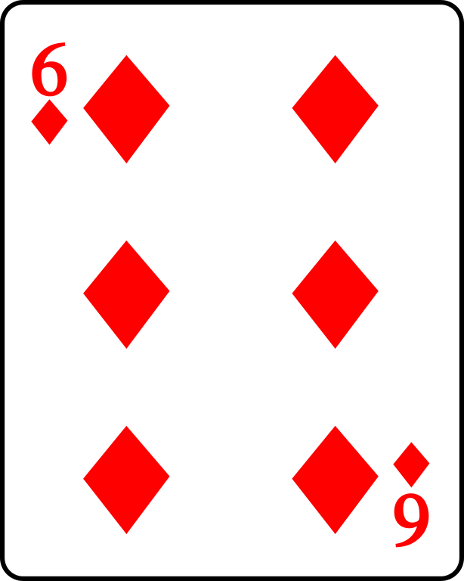
Lucky 13

- Deal 4 cards to each player.

- Players use 2 of their cards to get a sum as close to 13 as they can.

- Your score matches how far you are from 13 (e.g., if your two cards add to 15, your score is 2. If you get lucky and get 13, your score is 0!).

- Play 5 rounds. Lowest score wins!

More ways to play: Deal 5 cards, or play Lucky 10 or Lucky 15.
Factor War
[Think classic game of war.]

- Share the cards equally among the players.
- Each player flips over2 cards and announces their product.
- The greatest [correct] product wins those cards.
- A tie means – War. Repeat steps 2 and 3.
- Winner has most cards when time is up!
More ways to play: Fixed Factor War. You pick a number (e.g., 9 if you are working on your 9 facts). Place it in center for reference. Players only flip one card and multiply their card by the fixed factor. The greatest[correct] product wins. Play Sum (or Fixed Addend) War to practice addition facts.

Questions to Ask for Fact Fluency Games

- How did you solve that fact?
- Why did you choose that strategy?
- Are there other ways you could solve for that fact?
- What other facts might be solved with that* strategy?
- When do you like to use that* strategy (when is that strategy a good idea)?
*you can replace ‘that’ with the name of a strategy, like ‘When do you use the doubling strategy?’

